Lab Guide Vol4 Module 03: IoT and OT Hacking

Scenario
The significant development of the paradigm of the Internet of Things (IoT) is contributing to the proliferation of devices in daily life. From smart homes to automated healthcare applications, IoT is ubiquitous. However, despite the potential of IoT to make our lives easier and more comfortable, we cannot underestimate its vulnerability to cyber-attacks. IoT devices lack basic security, which makes them prone to various cyber-attacks.
The objective of a hacker in exploiting IoT devices is to gain unauthorized access to users’ devices and data. A hacker can use compromised IoT devices to build an army of botnets, which, in turn, is used to launch DDoS attacks.
Owing to a lack of security policies, smart devices are easy targets for hackers who can compromise these devices to spy on users’ activities, misuse sensitive information (such as patients’ health records, etc.), install ransomware to block access to the devices, monitor victims’ activities using CCTV cameras, commit credit-card-related fraud, gain access to users’ homes, or recruit the devices in an army of botnets to carry out DDoS attacks.
As an ethical hacker and penetration tester, you must have sound knowledge of hacking IoT and OT platforms using various tools and techniques. The labs in this module will provide you with real-time experience in performing footprinting and analyzing traffic between IoT and OT devices.

Objective
The objective of the lab is to perform IoT and OT platform hacking and other tasks that include, but are not limited to:
- Performing IoT and OT device footprinting
- Capturing and analyzing traffic between IoT devices
- Performing IoT attacks

Overview of IoT and OT Hacking
Using the IoT and OT hacking methodology, an attacker acquires information using techniques such as information gathering, attack surface area identification, and vulnerability scanning, and uses such information to hack the target device and network.
The following are the various phases of IoT and OT device hacking:
- Information gathering
- Vulnerability scanning
- Launch attacks
- Gain remote access
- Maintain access

Lab Tasks
Ethical hackers or pen testers use numerous tools and techniques to hack the target IoT and OT platforms. Recommended labs that will assist you in learning various IoT platform hacking techniques include:
- Perform footprinting using various footprinting techniques
  - Gather information using online footprinting tools
- Capture and analyze IoT device traffic
  - Capture and analyze IoT traffic using Wireshark
- Perform IoT Attacks
  - Perform replay attack on CAN protocol

Lab 1: Perform Footprinting using Various Footprinting Techniques
Lab Scenario
As a professional ethical hacker or pen tester, your first step is to gather maximum information about the target IoT and OT devices by performing footprinting through search engines, advanced Google hacking, Whois lookup, etc.
The first step in IoT and OT device hacking is to extract information such as IP address, protocols used (MQTT, ModBus, ZigBee, BLE, 5G, IPv6LoWPAN, etc.), open ports, device type, geolocation of the device, manufacturing number, and manufacturer of the device.
Lab Objectives
- Gather information using online footprinting tools
Overview of Footprinting Techniques
Footprinting techniques are used to collect basic information about the target IoT and OT platforms to exploit them. Information collected through footprinting techniques includes IP address, hostname, ISP, device location, banner of the target IoT device, FCC ID information, certification granted to the device, etc.
Task 1: Gather Information using Online Footprinting Tools
The information regarding the target IoT and OT devices can be acquired using various online sources such as Whois domain lookup, advanced Google hacking, and Shodan search engine. The gathered information can be used to scan the devices for vulnerabilities and further exploit them to launch attacks.
In this task, we will focus on performing footprinting on the MQTT protocol, which is a machine-to-machine (M2M)/“Internet of Things” connectivity protocol. It is useful for connections with remote locations where a small code footprint is required and/or network bandwidth is at a premium.
You can also select a protocol or device of your choice to perform footprinting on it.
- By default Windows 11 machine selected, click Ctrl+Alt+Delete. Login with Admin/Pa$$w0rd.
Networks screen appears; click Yes to allow your PC to be discoverable by other PCs and devices on the network.
- Launch any web browser; go to https://www.whois.com/whois (here, we are using Mozilla Firefox).
- The Whois Domain Lookup page appears; type www.oasis-open.org in the search field and click SEARCH.
Oasis is an organization that has published the MQTT v5.0 standard, which represents a significant leap in the refinement and capability of the messaging protocol that already powers IoT.
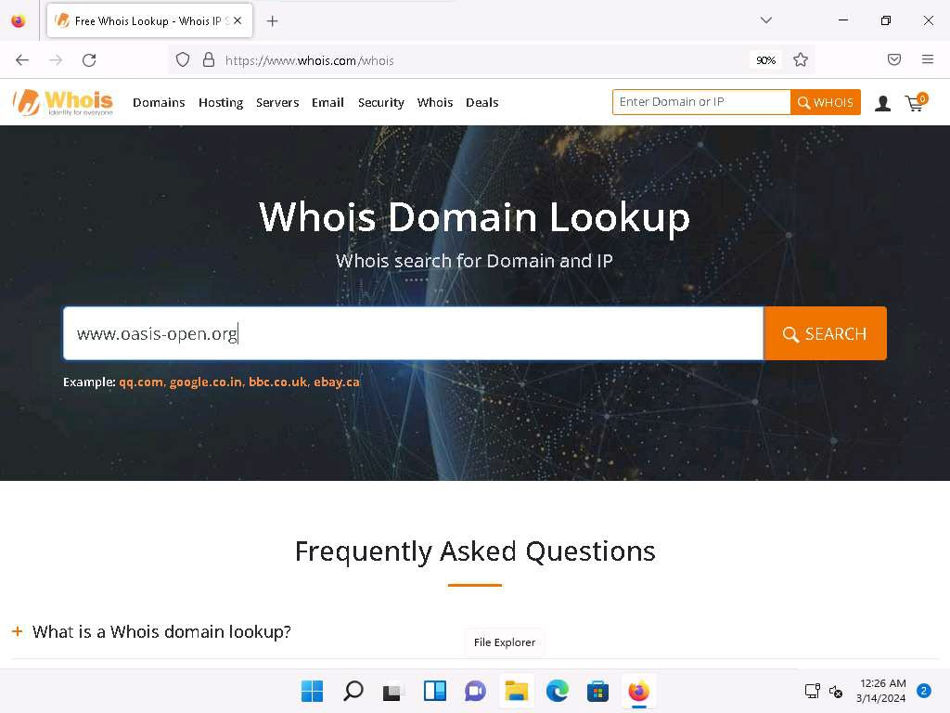
- The result appears, displaying the following information, as shown in the screenshots: Domain Information, Registrant Contact, and Raw Whois Data.
This information is about the organization that has developed the MQTT protocol, and it might help keep track of the modifications and version changes of the target protocol.
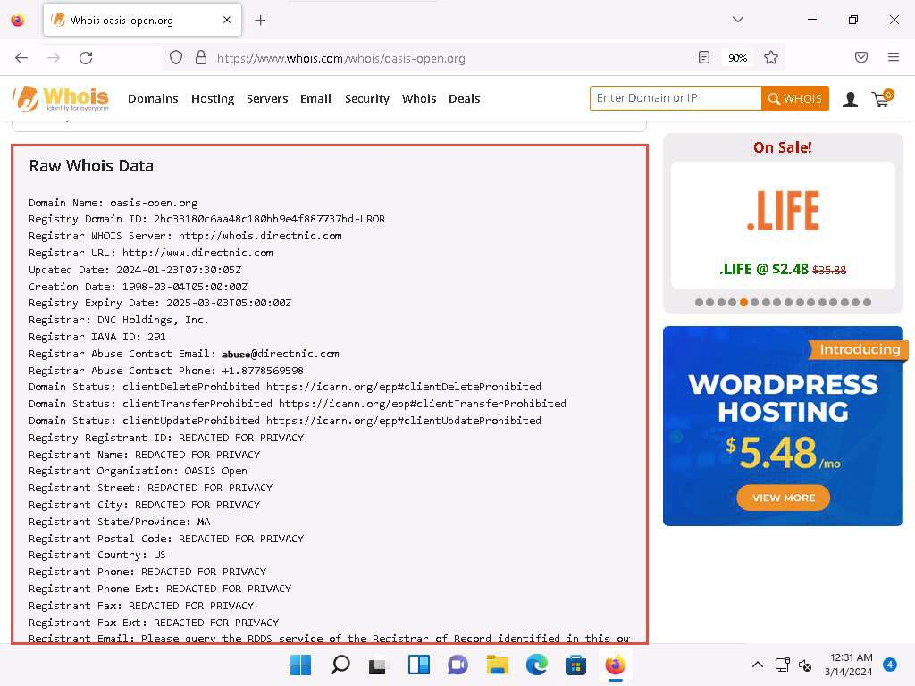
Whois lookup reveals available information on a hostname, IP address, or domain.
- Now, open a new tab, and go to https://www.exploit-db.com/google-hacking-database.
- The Google Hacking Database page appears; type SCADA in the Quick Search field and press Enter.
- The result appears, which displays the Google dork related to SCADA, as shown in the screenshot.
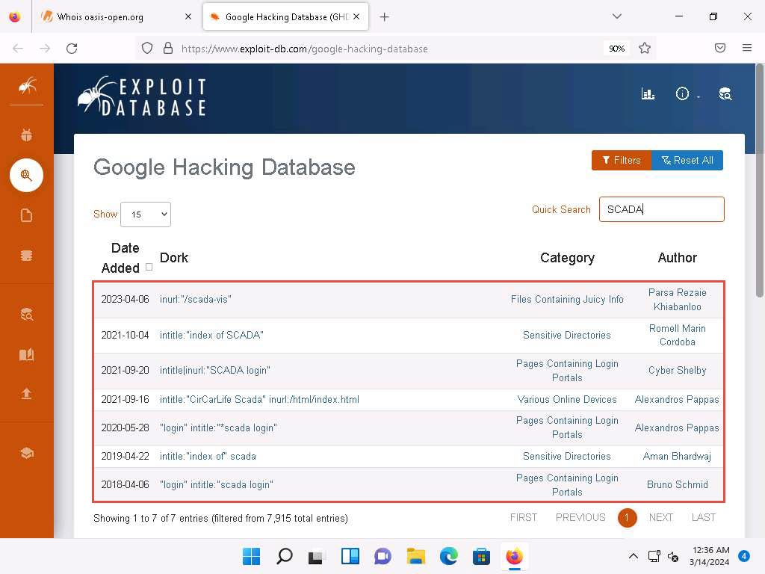
- Now, we will use the dorks obtained in the previous step to query results in Google.
- Open a new tab and go to https://www.google.com. In the search field, enter "login" intitle:"scada login".
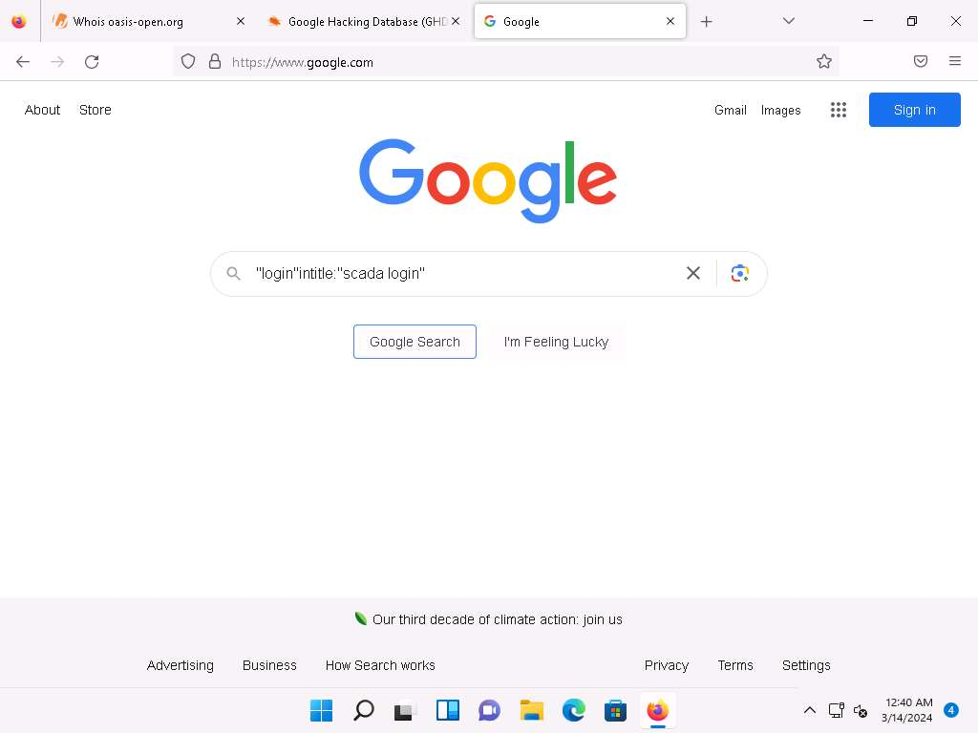
- The search result appears; click any link (here, SEAMTEC SCADA login).
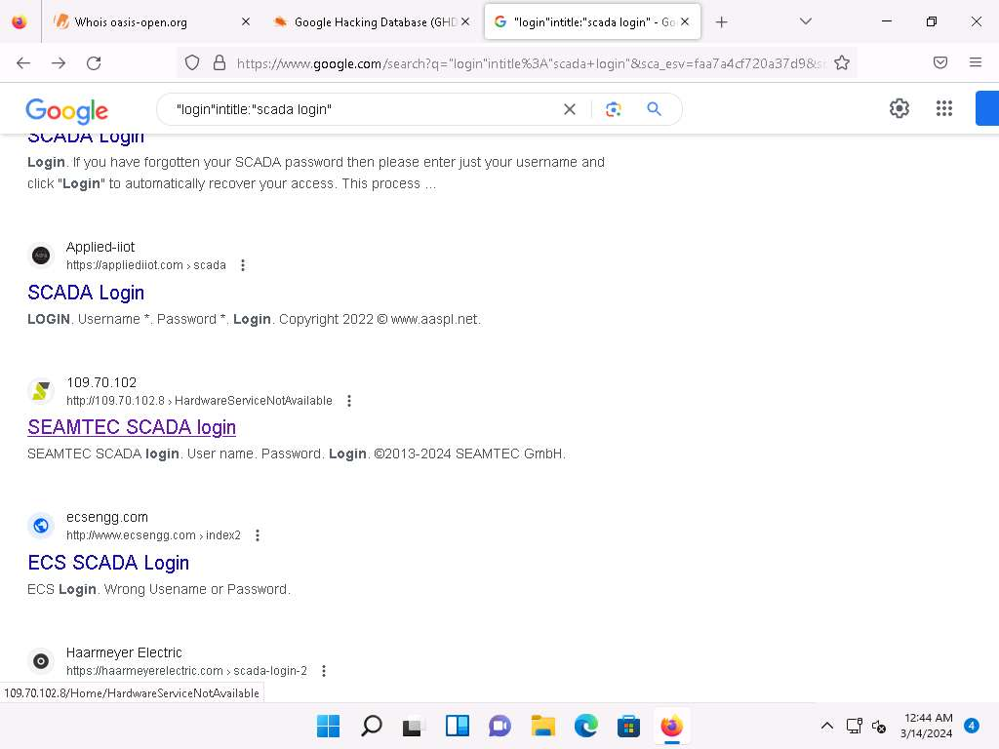
Advanced Google hacking refers to the art of creating complex search engine queries by employing advanced Google operators to extract sensitive or hidden information about a target company from the Google search results.
- The SEAMTEC SCADA login page appears, as shown in the screenshot.
In the login form, you can brute-force the credentials to gain access to the target SCADA system.
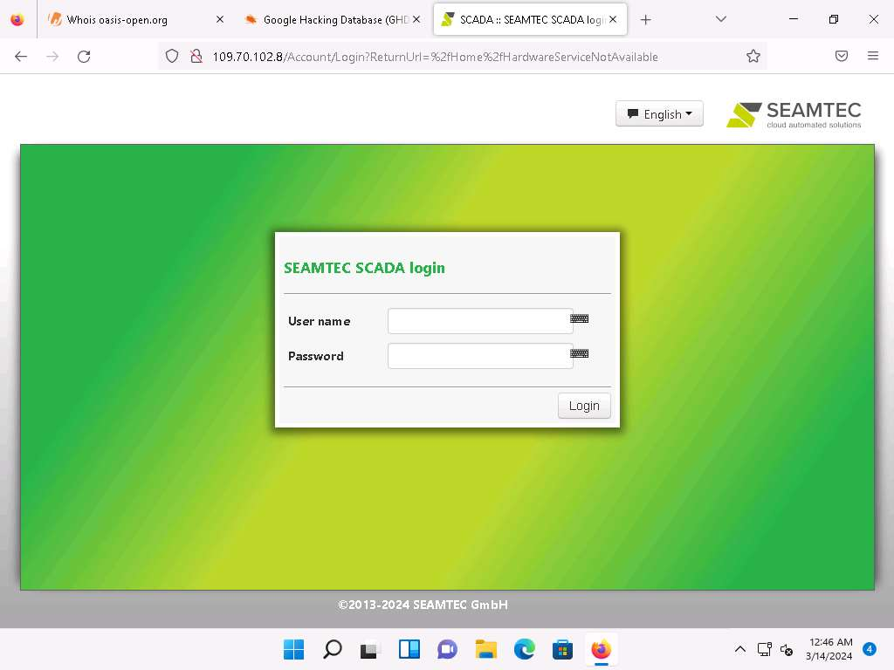
- Similarly, you can use advanced search operators such as intitle:"index of" scada to search sensitive SCADA directories that are exposed on sites.
- Now, in the browser window, open a new tab and go to https://account.shodan.io/login.
- The Login with Shodan page appears; enter your username and password in the Username and Password fields, respectively; and click Login.
If you do not have an existing account, then go to the Register option to register yourself.
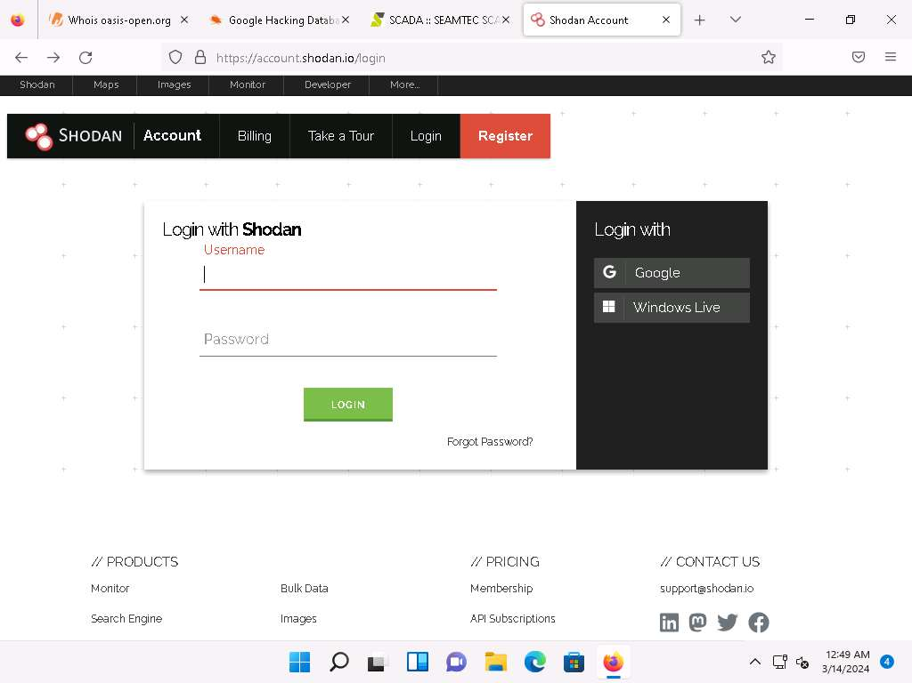
- The Account Overview page appears, which displays the account-related information. Click on Shodan in the top-left corner of the window to go to the main page of Shodan.
If the Would you like Firefox to save this login for shodan.io? notification appears, click Don’t Save.
- The Shodan main page appears; type port:1883 in the address bar and press Enter.
Port 1883 is the default MQTT port; 1883 is defined by IANA as MQTT over TCP.
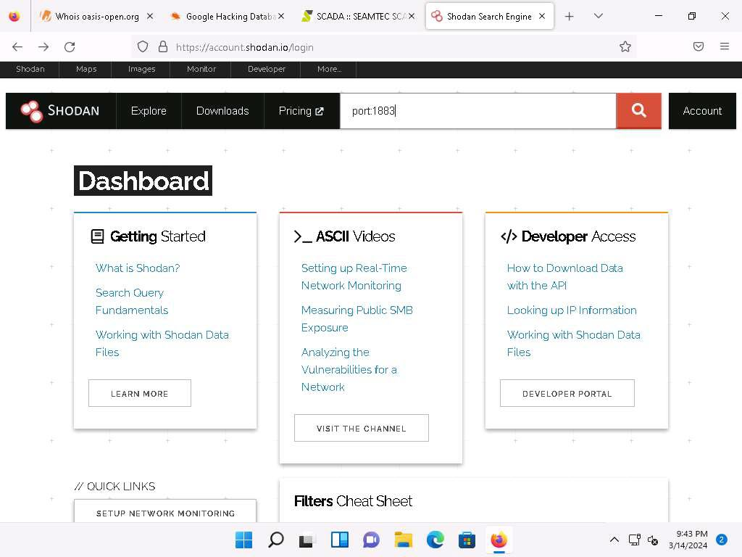
- The result appears, displaying the list of IP addresses having port 1883 enabled.
- Click on any IP address to view its detailed information.
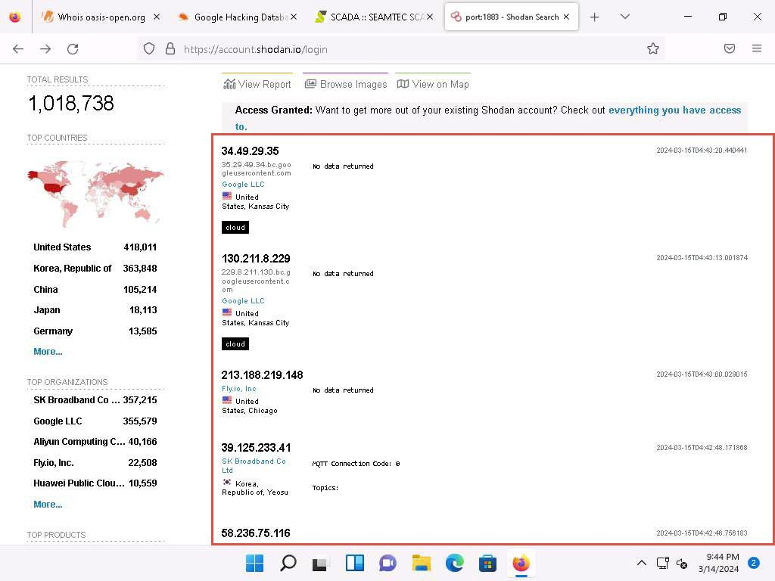
- Detailed results for the selected IP address appears, displaying information regarding Ports, Services, Hostnames, ASN, etc. as shown in the screenshot.
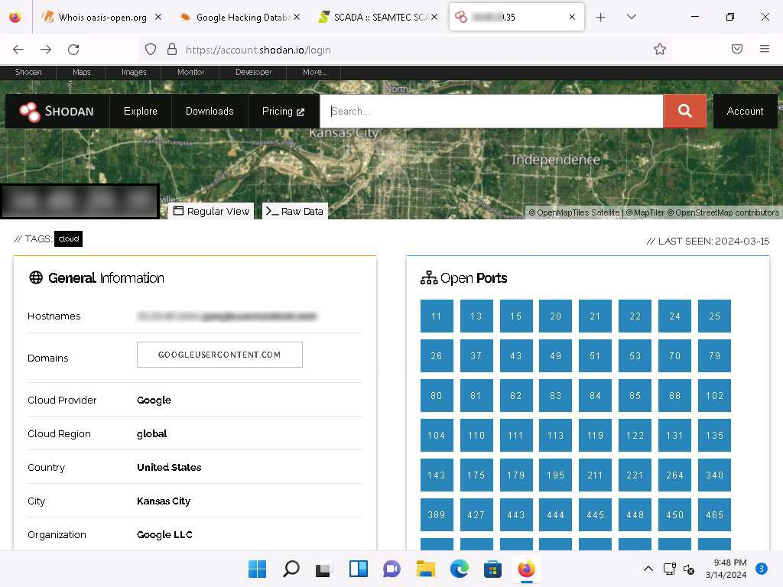
- Similarly, you can gather additional information on a target device using the following Shodan filters:
  - Search for Modbus-enabled ICS/SCADA systems:
port:502
  - Search for SCADA systems using PLC name:
“Schneider Electric”
  - Search for SCADA systems using geolocation:
SCADA Country:"US"
- Using Shodan, you can obtain the details of SCADA systems that are used in water treatment plants, nuclear power plants, HVAC systems, electrical transmission systems, home heating systems, etc.
- This concludes the demonstration of gathering information on a target device using various techniques such as Whois lookup, advanced Google hacking, and Shodan search engine.
- Close all open windows and document all the acquired information.
Question 18.1.1.1
Use the Shodan search engine to collect the IP addresses with MQTT enabled. Perform a search using the MQTT port number. Which port number will you enter in the search field to obtain the desired result?
Lab 2: Capture and Analyze IoT Device Traffic
Lab Scenario
As a professional ethical hacker or pen tester, you must have sound knowledge to capture and analyze the traffic between IoT devices. Using various tools and techniques, you can capture the valuable data flowing between the IoT devices, analyze it to obtain information on the communication protocol used by the IoT devices, and acquire sensitive information such as credentials, device identification numbers, etc.
Lab Objectives
- Capture and analyze IoT traffic using Wireshark
Overview of IoT and OT Traffic
Many IoT devices such as security cameras host websites for controlling or configuring cameras from remote locations. These websites mostly implement the insecure HTTP protocol instead of the secure HTTPS protocol and are, hence, vulnerable to various attacks. If the cameras use the default factory credentials, an attacker can easily intercept all the traffic flowing between the camera and web applications and further gain access to the camera itself. Attackers can use tools such as Wireshark to intercept such traffic and decrypt the Wi-Fi keys of the target network.
Task 1: Capture and Analyze IoT Traffic using Wireshark
Wireshark is a free and open-source packet analyzer. It facilitates network troubleshooting, analysis, software and communications protocol development, and education. It is used to identify the target OS and sniff/capture the response generated from the target machine to the machine from which a request originates.
MQTT is a lightweight messaging protocol that uses a publish/subscribe communication pattern. Since the protocol is meant for devices with a low-bandwidth, it is considered ideal for machine-to-machine (M2M) communication or IoT applications. We can create virtual IoT devices over the virtual network using the Bevywise IoT simulator on the client side and communicate these devices to the server using the MQTT Broker web interface. This interface collects data and displays the status and messages of connected devices over the network.
Here, we use Wireshark to capture and analyze traffic between IoT devices.
- To install the MQTT Broker on the Windows Server 2019, click Windows Server 2019 to launch Windows Server 2019 machine. Click Ctrl+Alt+Delete and login with Administrator/Pa$$w0rd.
- Navigate to Z:\CEHv13 Module 18 IoT and OT Hacking\Bevywise IoT Simulator folder and double-click on the Bevywise_MQTTRoute_4.exe file.
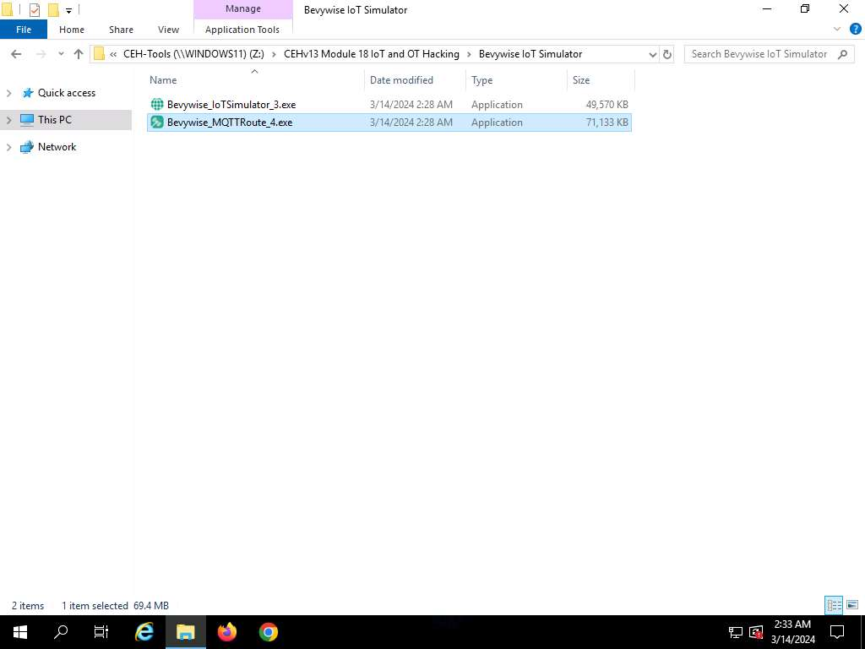
- If Open File - Security Warning popup appears, click Run.
- The Setup – MQTTRoute 4.0 window opens. Select I accept the agreement and click on Next. Follow the wizard driven steps to install the tool.
- After the installation completes, click on Finish. Ensure that Launch MQTTRoute is checked.
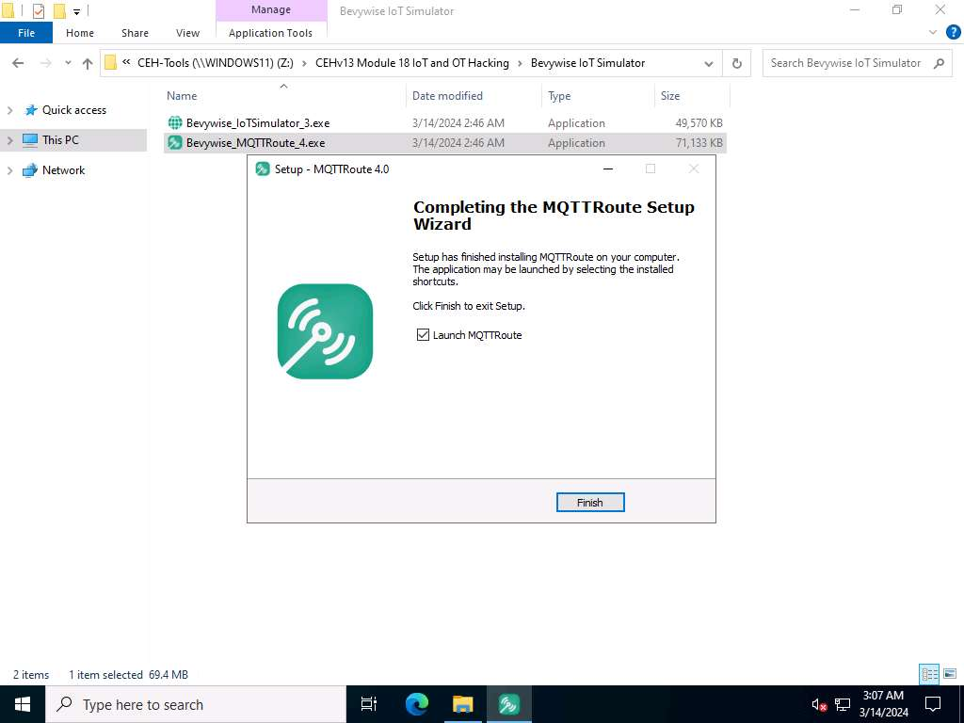
- The MQTTRoute will execute and the command prompt will appear. You can see the TCP port using 1883.
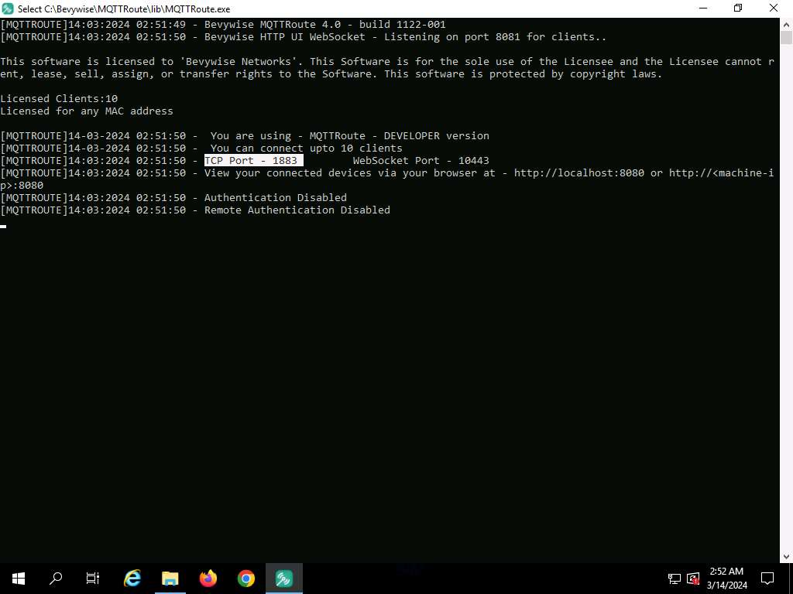
- We have installed MQTT Broker successfully and leave the Bevywise MQTT running.
- To create IoT devices, we must install the IoT simulator on the client machine.
- Click Windows Server 2022 to switch to Windows Server 2022 machine. Click Ctrl+Alt+Delete and login with Administrator/Pa$$w0rd.
If the network screen appears, click Yes.
- Navigate to Z:\CEHv13 Module 18 IoT and OT Hacking\Bevywise IoT Simulator folder and double-click on the Bevywise_IoTSimulator_3.exe file.
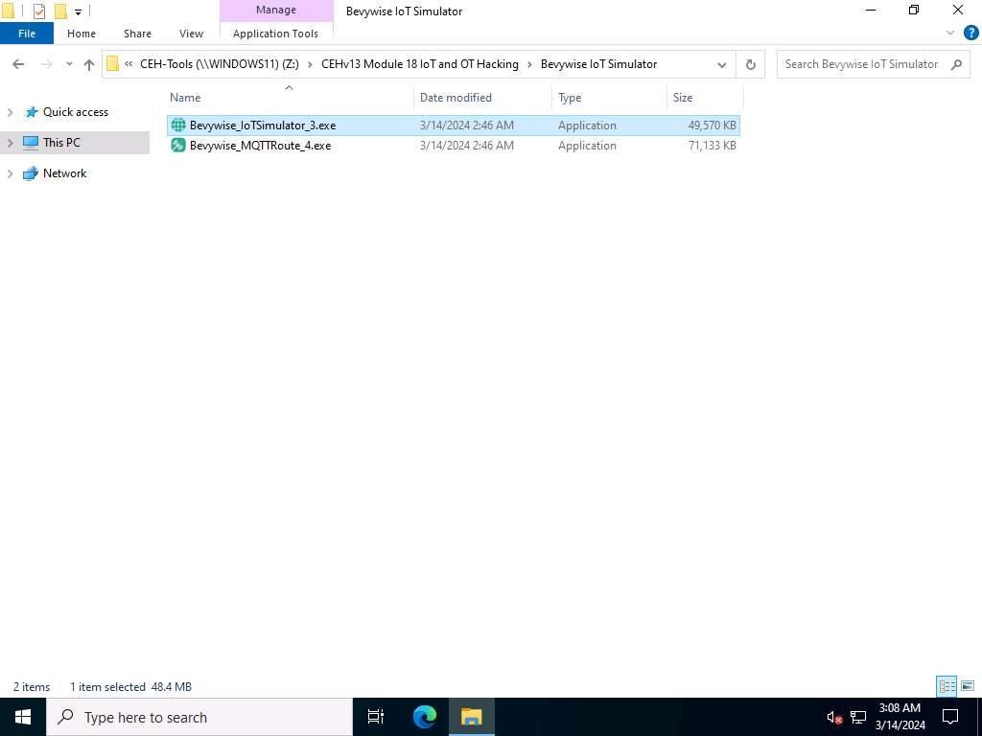
- If Open File - Security Warning popup appears, click Run..
- The Setup-IoTSimulator_3 3.0 setup wizard opens. Select I accept the agreement and follow the wizard driven steps.
- To complete the installation, select Yes, restart the computer now and click on Finish to complete the installation.
If restart computer option does not appear, then continue from Step#16.
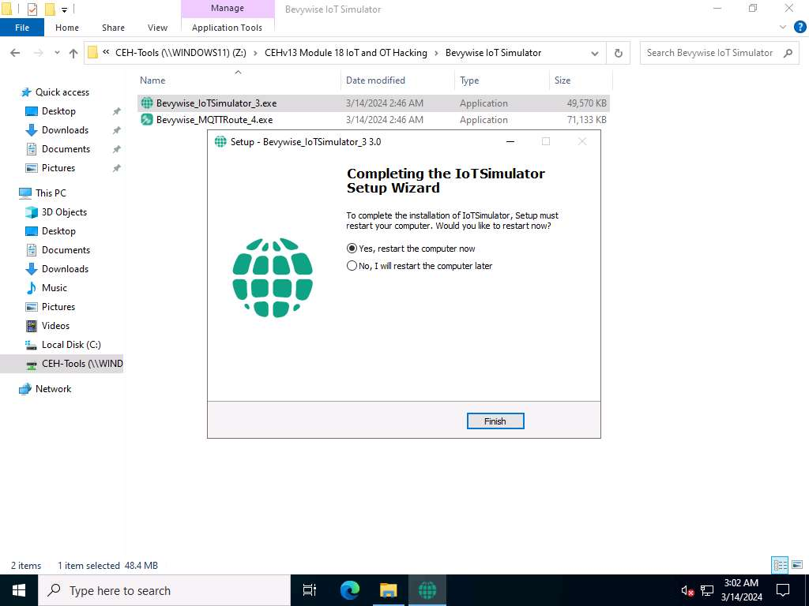
- After restarting, Bevywise IoT Simulator is installed successfully. To launch the IoT simulator, navigate to the C:\Bevywise\IotSimulator\bin directory and double-click on the runsimulator.bat file.
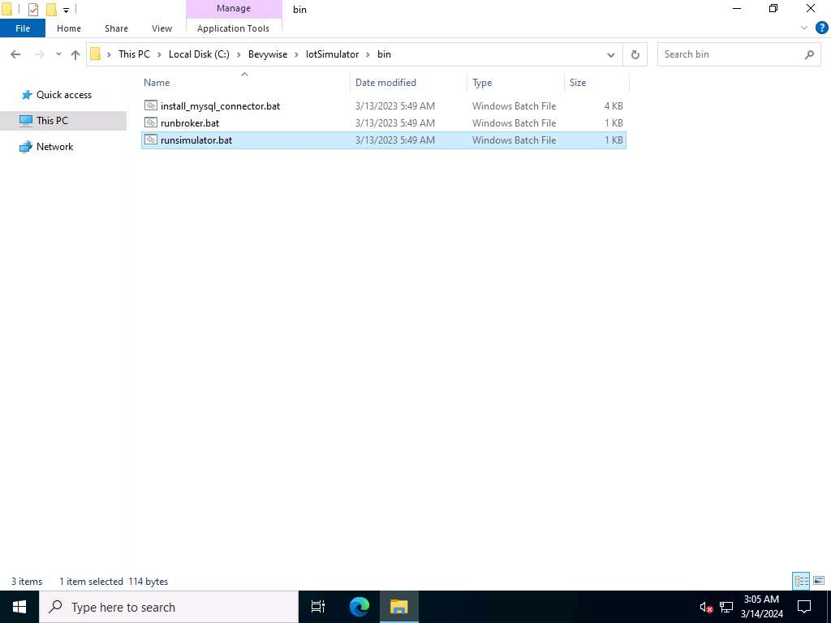
- Upon double-clicking, the runsimulator.bat file opens in the command prompt. If How do you want to open this? pop-up appears, select Microsoft Edge browser and click OK to open the URL http://127.0.0.1:9000/setnetwork?network=HEALTH_CARE.
If the URL directly opens in Microsoft Edge browser, then continue.
- The web interface of the IoT Simulator opens in Edge browser. In the IoT Simulator, you can view the default network named HEALTH_CARE and several devices.
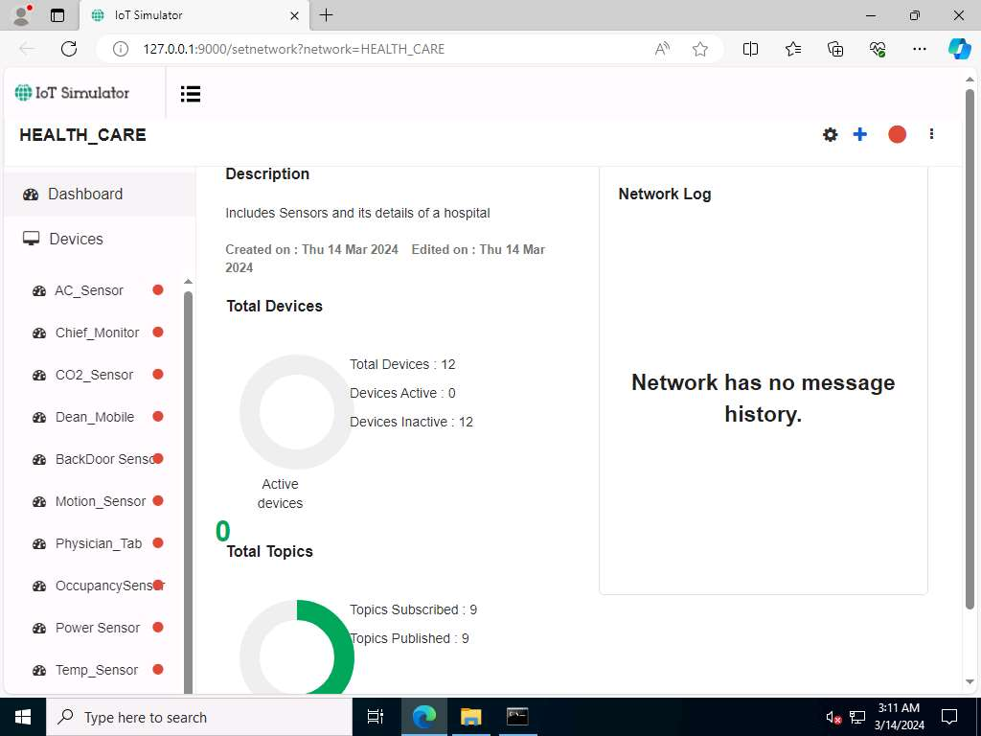
- Next, we will create a virtual IoT network and virtual IoT devices. Click on the menu icon and select the +New Network option.
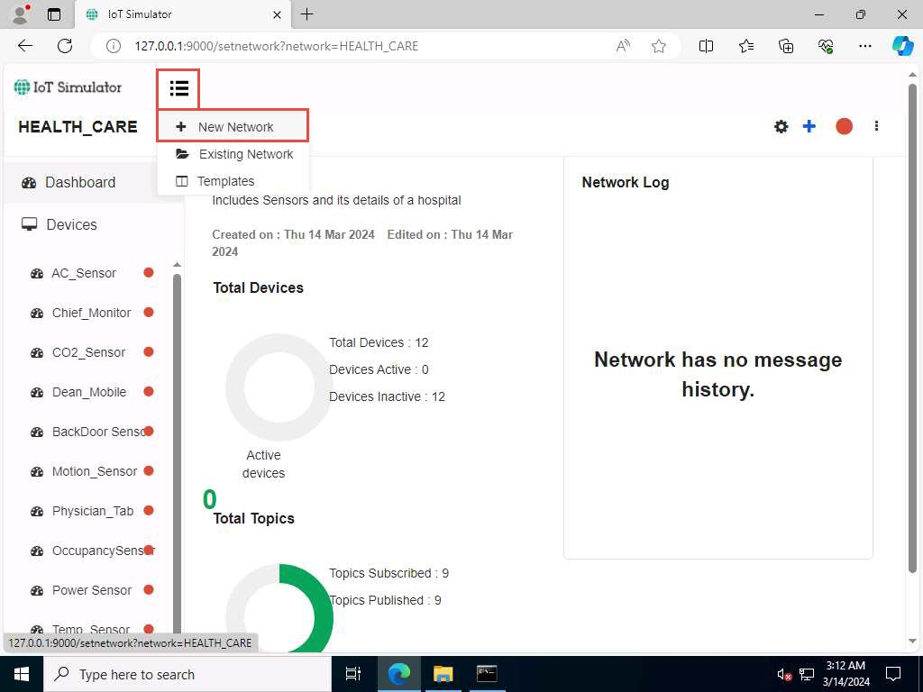
- The Create New Network popup appears. Type any name (here, CEH_FINANCE_NETWORK) and description. Click on Create.
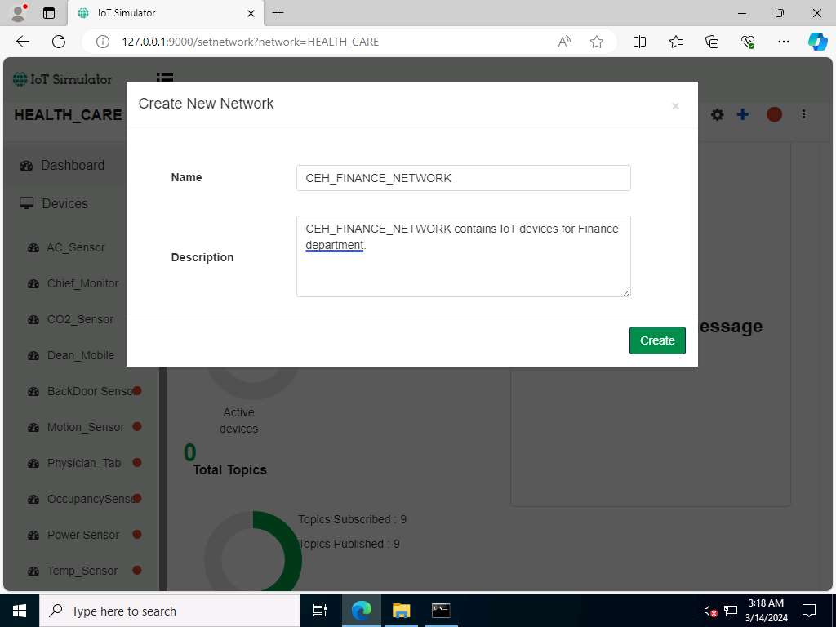
- In the next screen, we will set up the Simulator Settings. Set the Broker IP Address as 10.10.1.19 (the IP address of the Windows Server 2019). Since we have installed the Broker on the web server, the created network will interact with the server using MQTT Broker. Do not change default settings and click on Save.
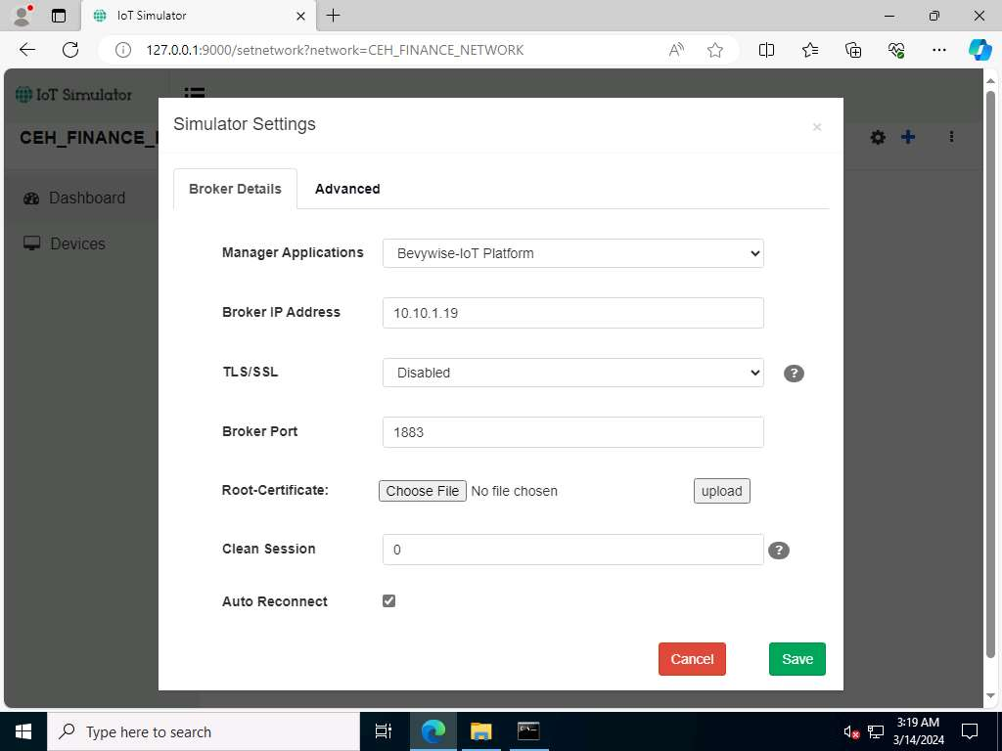
- To proceed with the network creation, click on Yes.
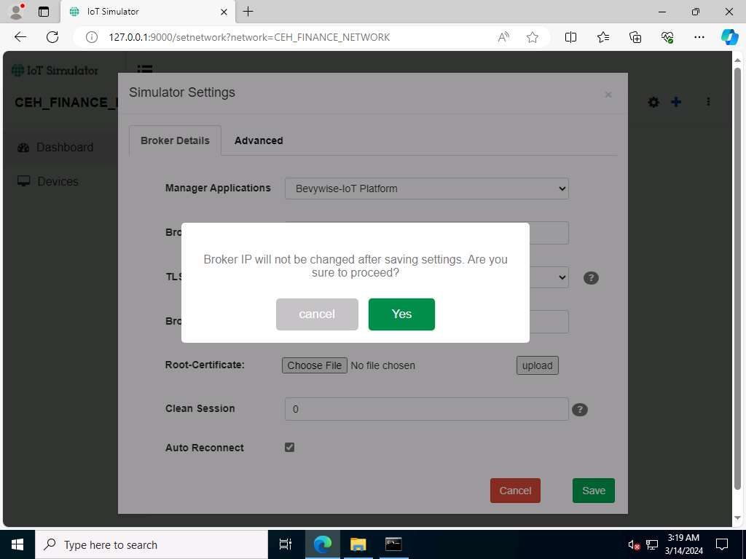
If Configuration Saved pop-up appears. Click on OK to continue. This step completes the creation of the virtual IoT network.
- To add IoT devices to the created network, click on the Add blank Device button.
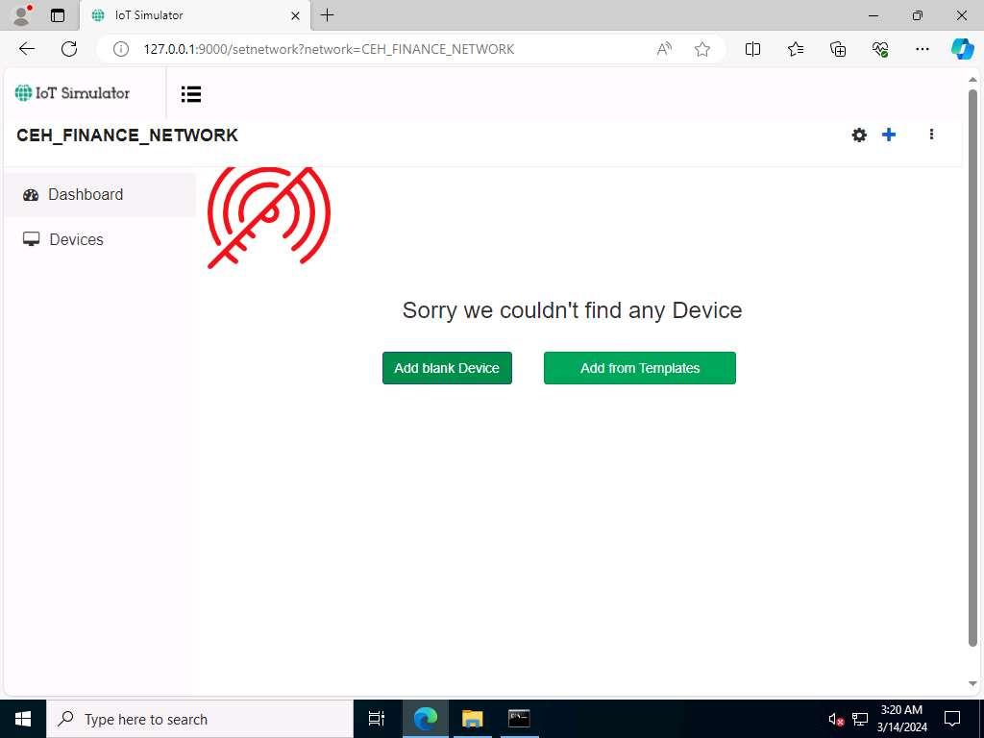
- The Create New Device popup opens. Type the device name (here, we use Temperature_Sensor), enter Device Id (here, we use TS1), provide a Description and click on Save.
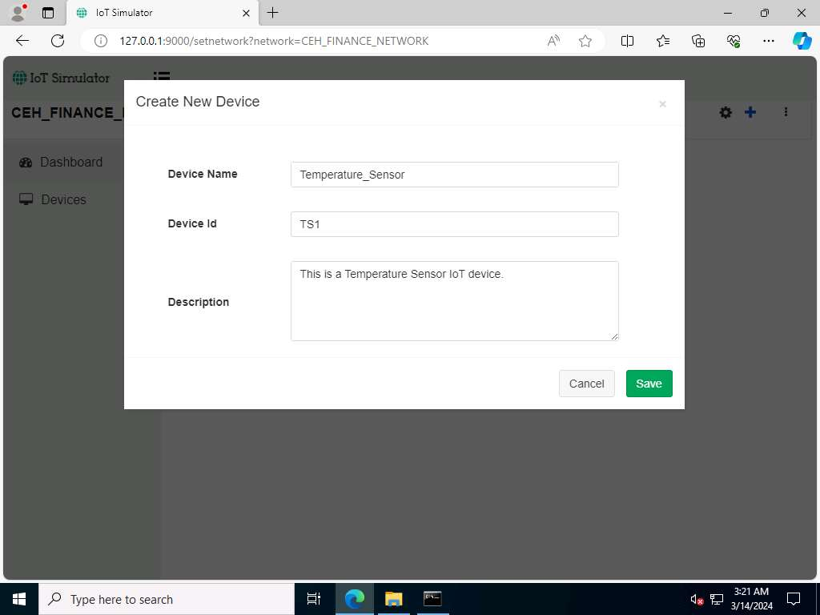
- The device will be added to the CEH_FINANCE_NETWORK.
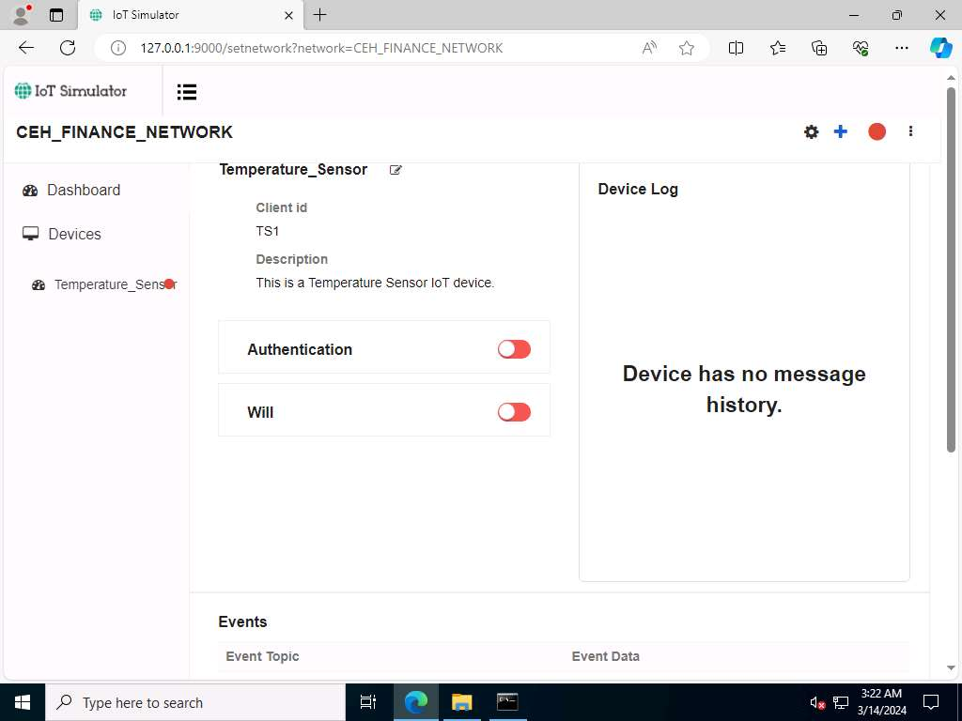
- To connect the Network and the added devices to the server or Broker, click on the Start Network red color circular icon in right corner.
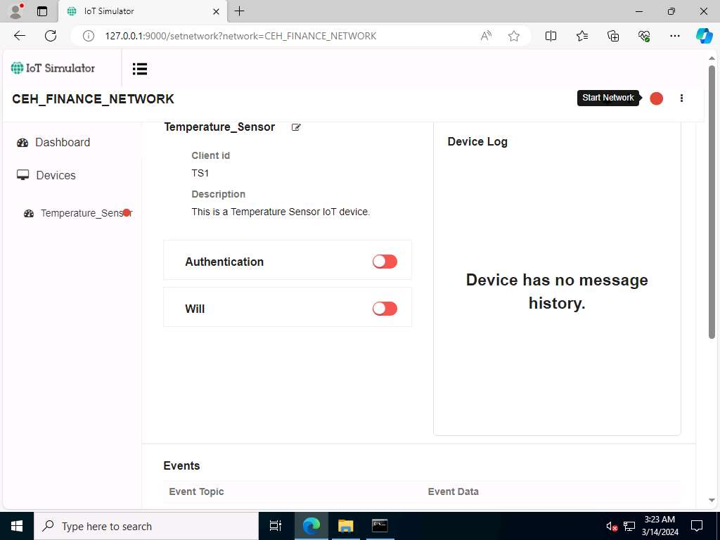
- When a connection is established between the network and the added devices and the web server or the MQTT Broker, the red button turns into green.
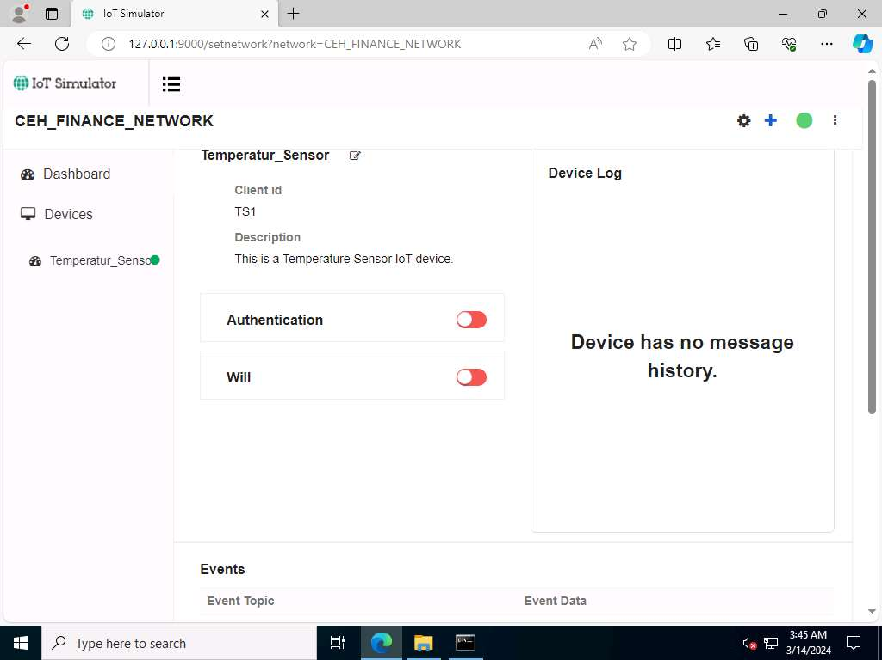
- Next, switch to the Windows Server 2019 machine. Open a web browser and go to http://localhost:8080 and login using admin/admin (here, we are using Firefox Browser).
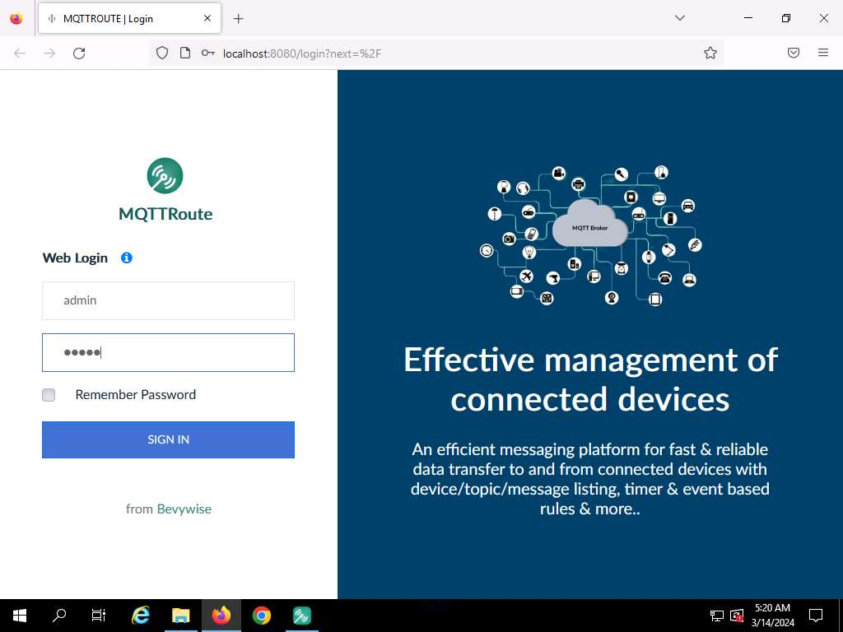
- Since the Broker was left running, you can see a connection request from machine 10.10.1.22 for the device TS1 under Recent Connections section.
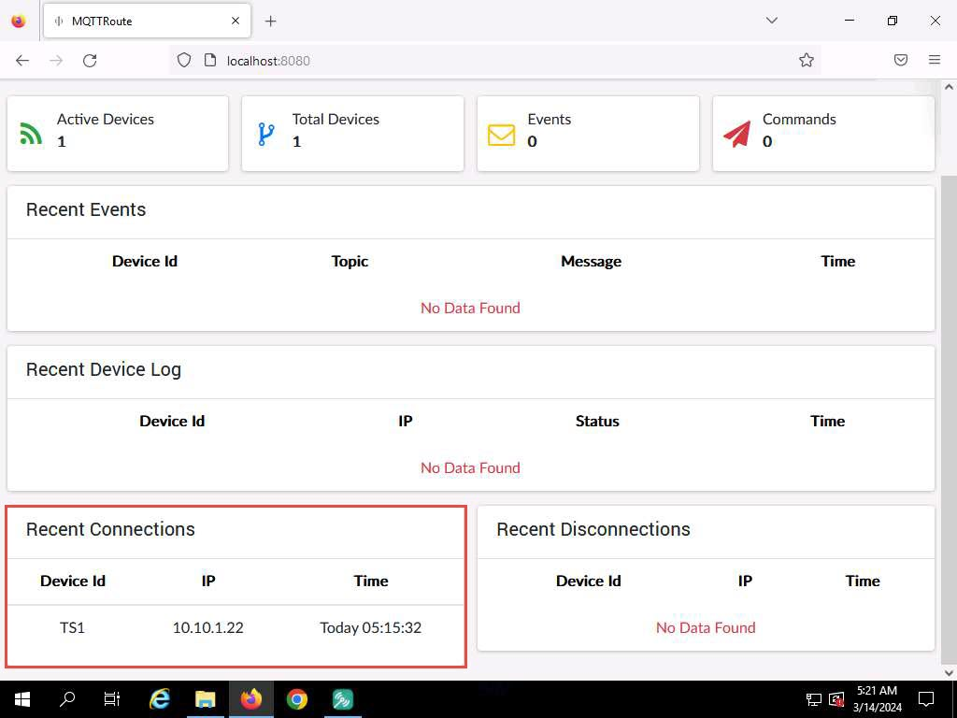
- Switch back to Windows Server 2022 machine.
- Next, we will create the Subscribe command for the device Temperature_Sensor.
- Click on the Plus icon in the top right corner and select the Subscribe to Command option.
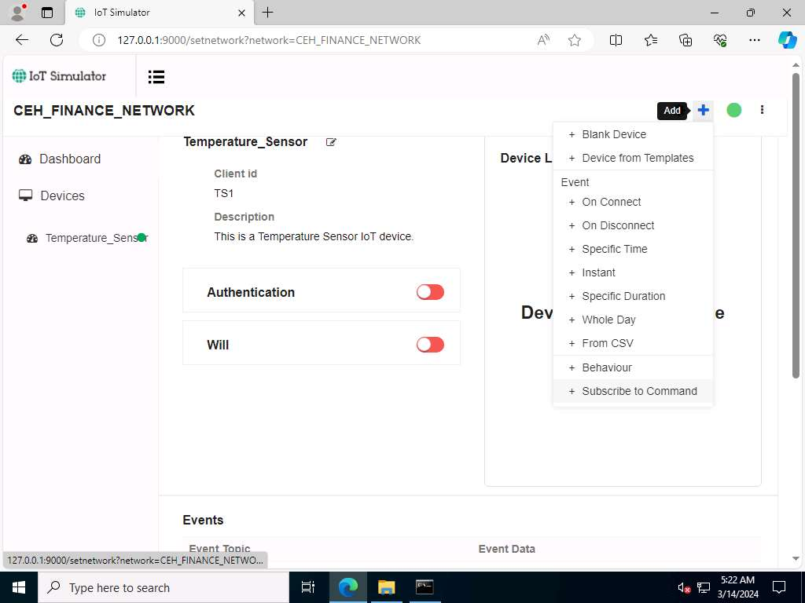
- The Subscribe for command - TS1 popup opens. Select On start under the Subscribe on tab, type High_Tempe under the Topic tab, and select 1 Atleast once below the Qos option. Click on Save.
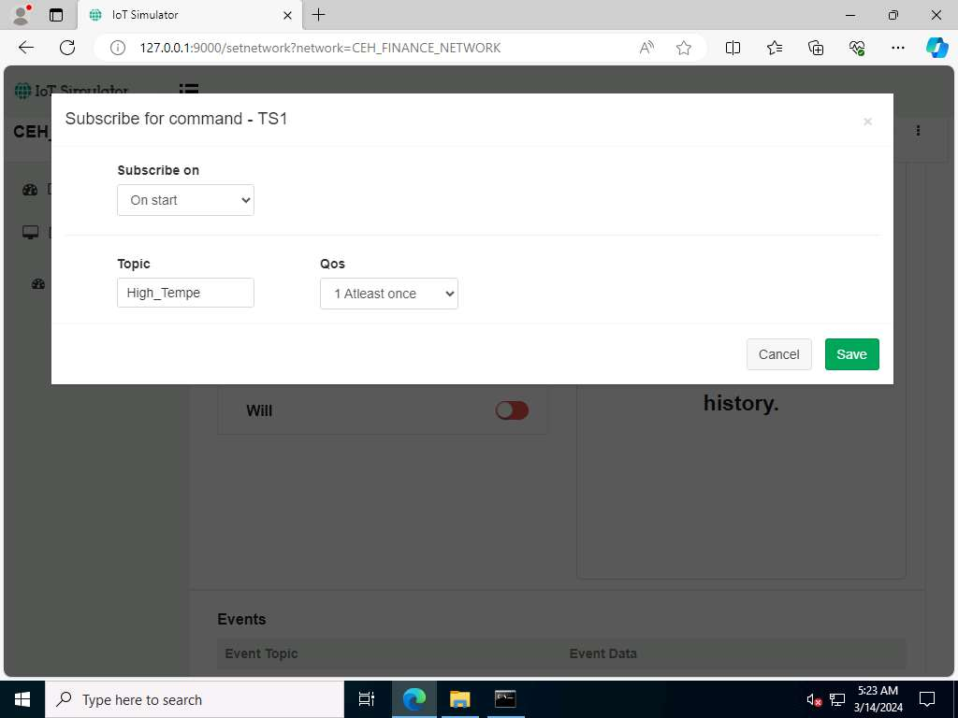
- Scroll down the page, you can see the Topic added under the Subscribe to Commands section.
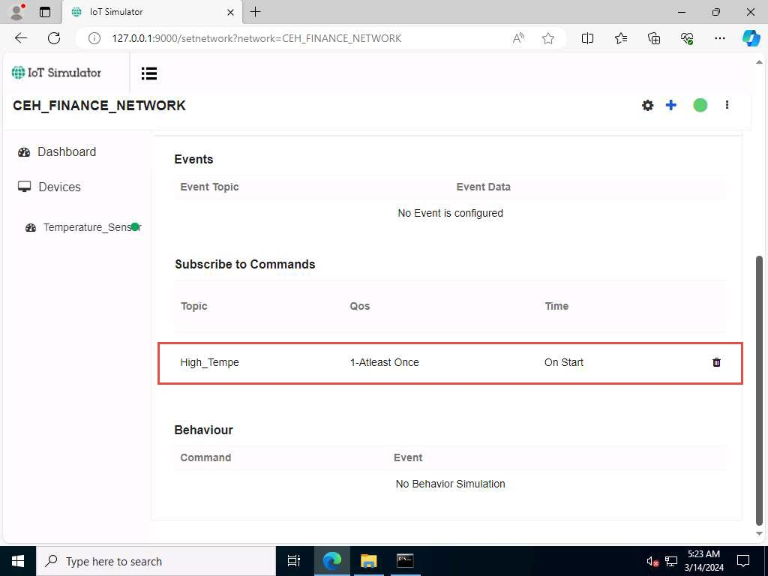
- Next, we will capture the traffic between the virtual IoT network and the MQTT Broker to monitor the secure communication.
- Minimise the Edge browser. Click Type here to search field on the Desktop, search for wireshark in the search bar and select Wireshark from the results.
- The Wireshark Application window appears; select the Ethernet as interface.
Make sure you have selected the interface which has 10.10.1.22 as the IP address.
If Software update popup appears, click on Skip this version.
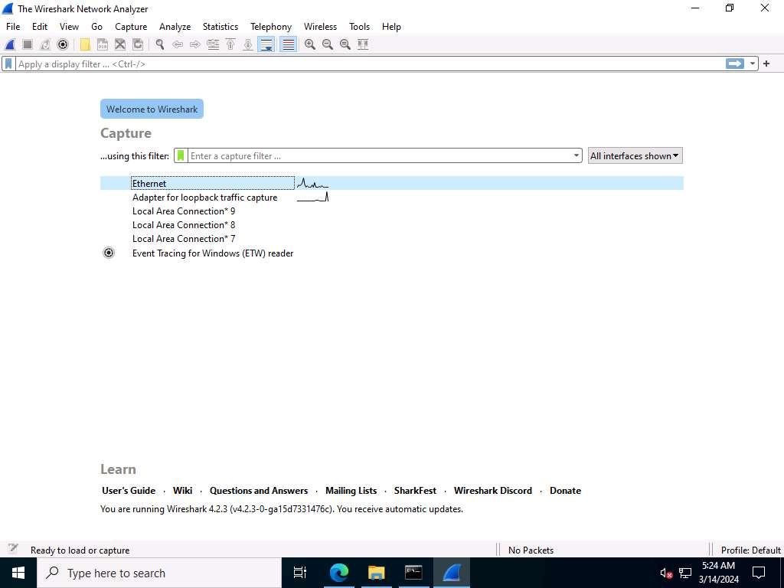
- Click on the Start Wireshark icon to start the capturing packets; leave the Wireshark running.
- Leave the IoT simulator running and switch to the Windows Server 2019 machine.
- Navigate to Devices menu and click on connected device i.e.TS1.
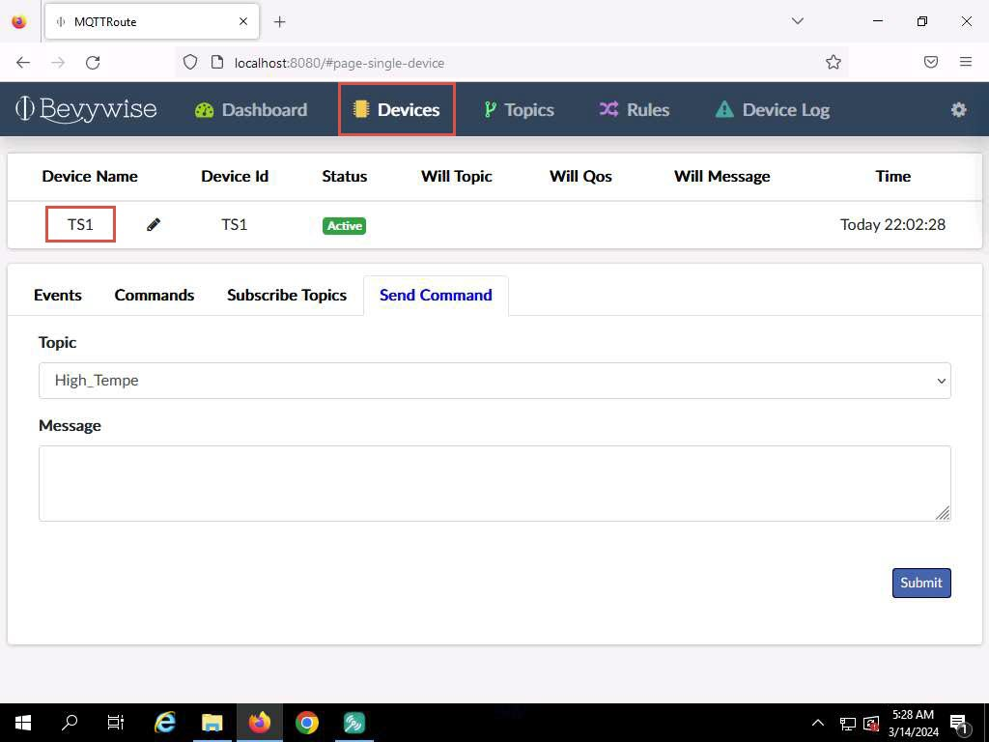
- Now, we will send the command to TS1 using the High_Tempe topic.
- In Send Command section, select Topic as High_Tempe, type Alert for High Temperature in Message field and click on the Submit button.
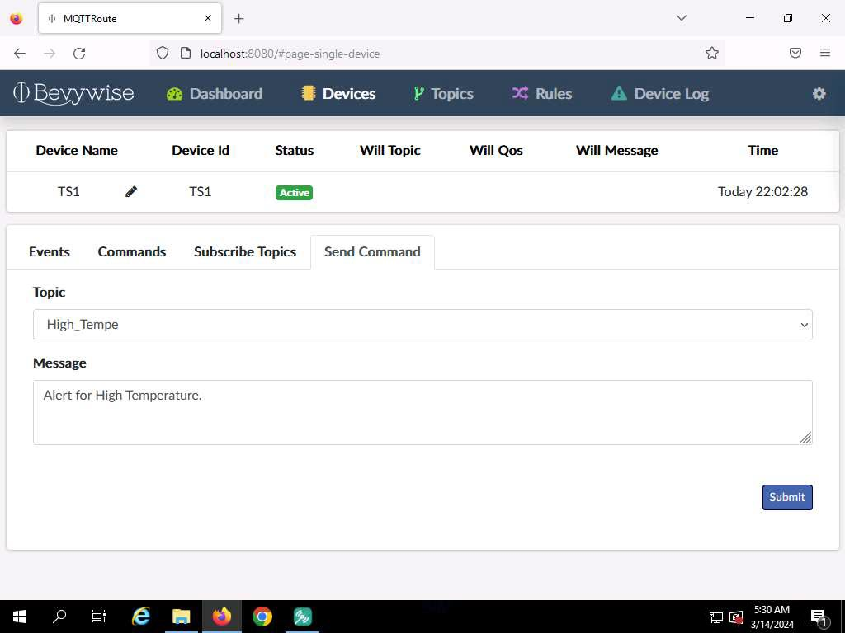
- Message sent to TS1 appears under Message box which indicates that the message was successfully sent to TS1.
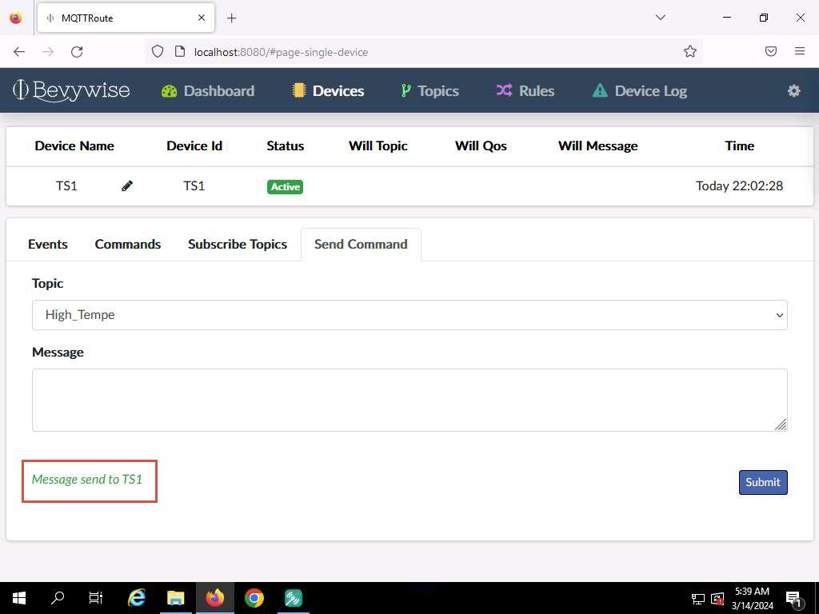
- The message has been sent to the device using this topic.
- Next, switch to Windows Server 2022 machine.
- We have left the IoT simulator running in the web browser. To see the alert message, maximise the Edge browser and expand the arrow under the connected Temperature_Sensor, Device Log section.
- You can see the alert message "Alert for High Temperature"
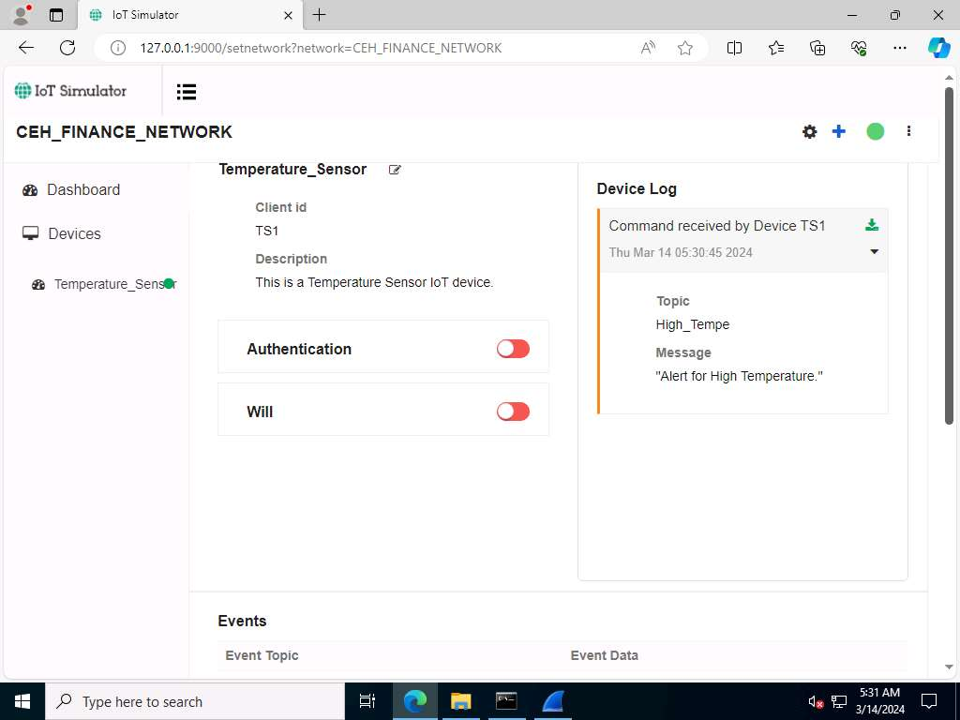
- To verify the communication, we have executed Wireshark application, switch to the Wireshark traffic capturing window.
- Type mqtt under the filter field and press Enter. To display only the MQTT protocol packets.
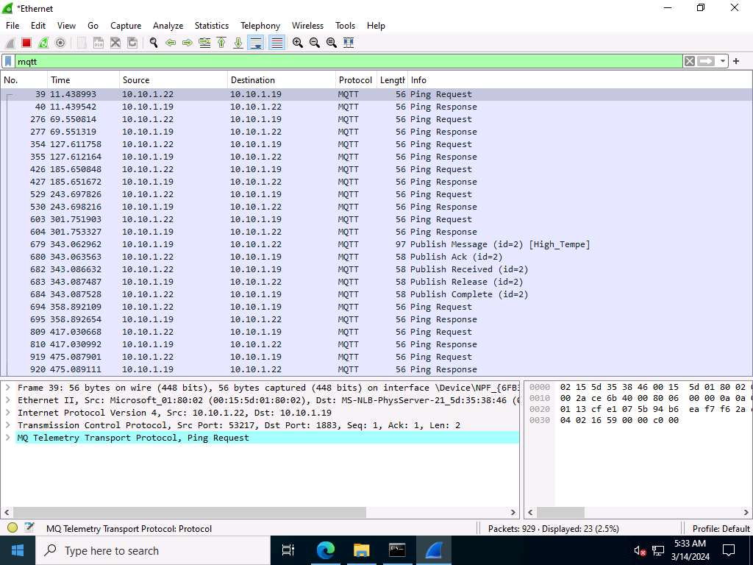
- Select any Publish Message packet from the Packet List pane. In the Packet Details pane at the middle of the window, expand the Transmission Control Protocol, MQ Telemetry Transport Protocol, and Header Flags nodes.
- Under the MQ Telemetry Transport Protocol nodes, you can observe details such as Msg Len, Topic Length, Topic, and Message.
- Publish Message can be used to obtain the message sent by the MQTT client to the broker.
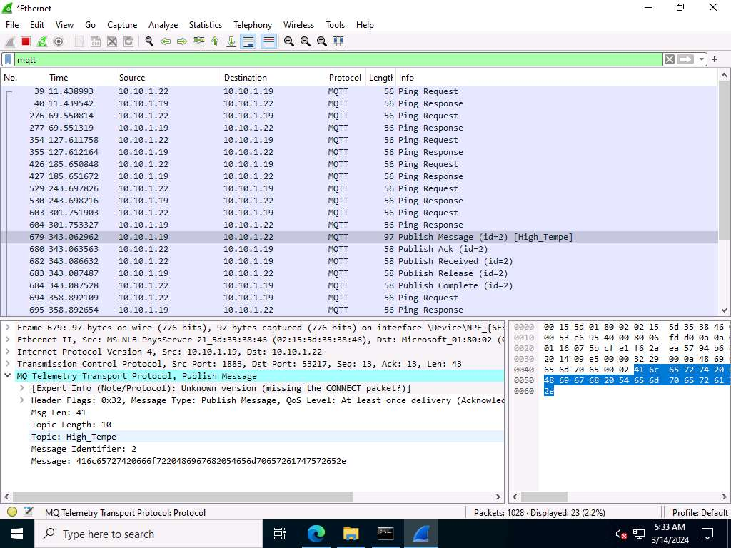
Note: After establishing a successful connection with the MQTT broker, the MQTT client can publish messages. The headers in the Publish Message packet are given below:
  - Header Flags: Contains information regarding the MQTT control packet type.
  - DUP flag: If the DUP flag is 0, it indicates the first attempt at sending this PUBLISH packet; if the flag is 1, it indicates a possible re-attempt at sending the message.
  - QoS: Determines the assurance level of a message.
  - Retain Flag: If the retain flag is set to 1, the server must store the message and its QoS, so it can cater to future subscriptions matching the topic.
  - Topic Name: Contains a UTF-8 string that can also include forward slashes when it needs to be hierarchically structured.
  - Message: Contains the actual data to be transmitted.
  - Payload: Contains the message that is being published.
- Select any Publish Release packet from the Packet List pane. In the Packet Details pane at the middle of the window, expand the Transmission Control Protocol, MQ Telemetry Transport Protocol, and Header Flags nodes.
- Under the MQ Telemetry Transport Protocol nodes, you can observe details such as Msg Len, Message Type, Message Identifier.
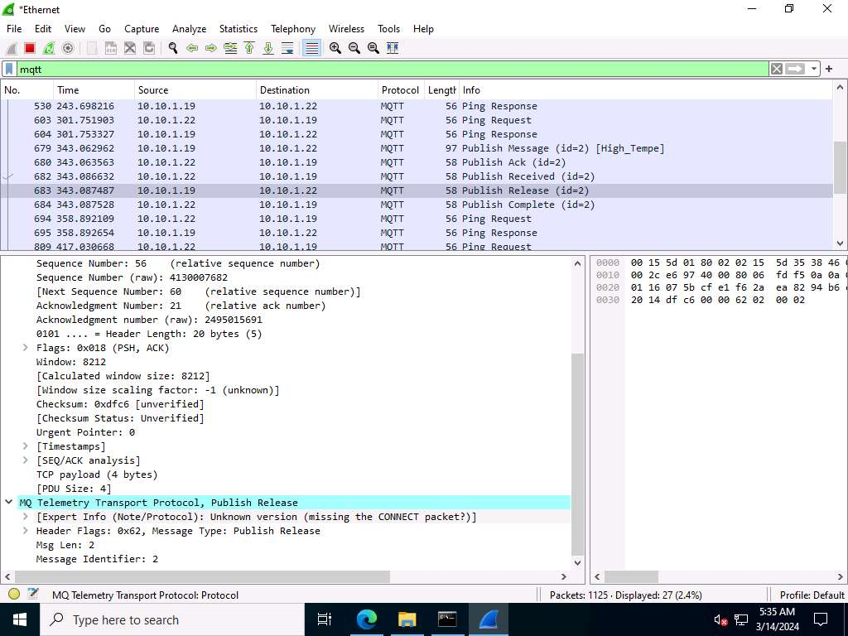
Note: A Publish Release (PUBREL) packet is the response to a Publish Received (PUBREC) packet.
- Now, scroll down, look for the Publish Complete packet from the Packet List pane, and click on it. In the Packet Details pane at the middle of the window, expand the Transmission Control Protocol, MQ Telemetry Transport Protocol, and Header Flags nodes.
- Under the MQ Telemetry Transport Protocol nodes, you can observe details such as Msg Len and Message Identifier.
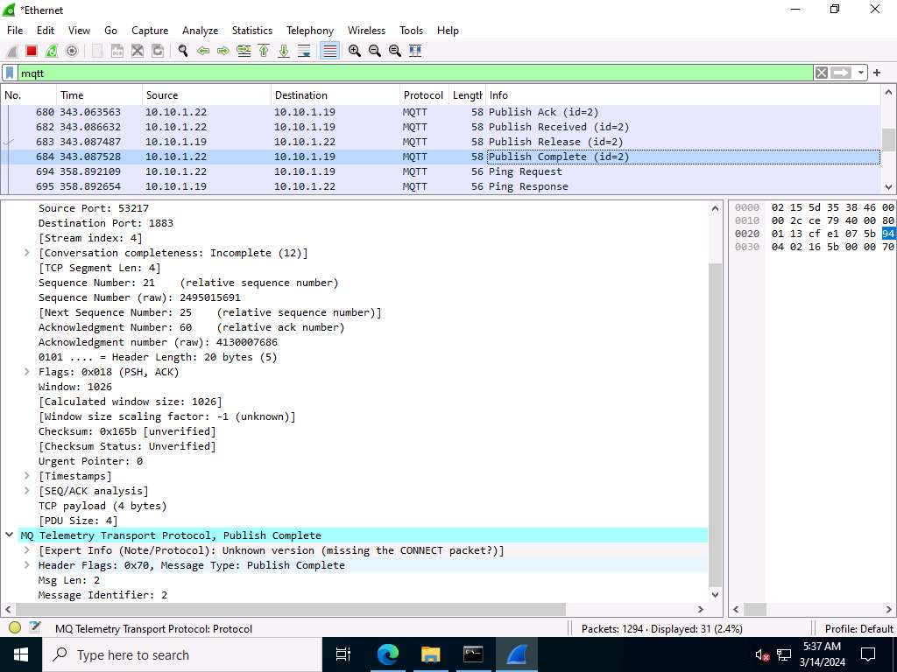
Note: The Publish Complete (PUBCOMP) packet is the response to a Publish Release (PUBREL) packet.
- Now, scroll down, look for the Publish Received packet from the Packet List pane, and click on it. In the Packet Details pane at the middle of the window, expand the Transmission Control Protocol, MQ Telemetry Transport Protocol, and Header Flags nodes.
- Under the MQ Telemetry Transport Protocol nodes, you can observe details such as Message Type, Msg Len and Message Identifier.
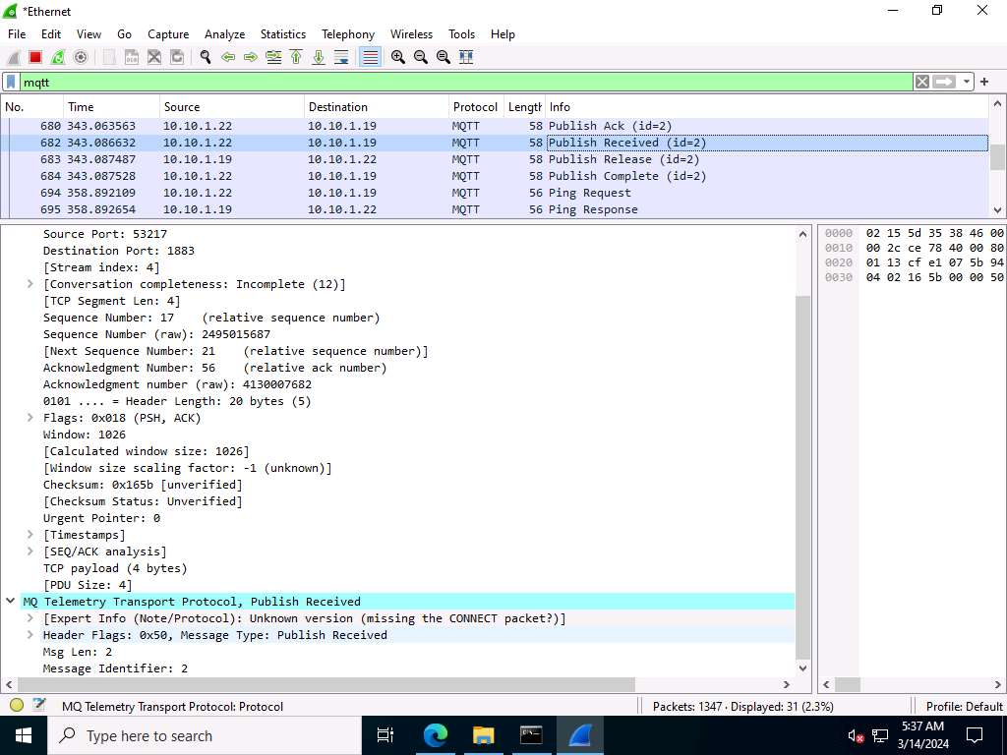
- Similarly you can select Ping Request, Ping Response and Publish Ack packets and observe the details.
- This concludes the demonstration of capturing and analyzing MQTT protocol packets. Here, we analyzed different processes involved in the communication between an MQTT client and an MQTT broker using Wireshark. Understanding these metrics as well as the workflow can help you in quickly identifying the MQTT-related issues.
- Close all open windows and document all the acquired information.
Question 18.2.1.1
Use Wireshark and Bevywise MQTT Route and Bevywise IoT Simulator to capture and analyze traffic between IoT devices. What is the default TCP port used by Bevywise MQTT Route to establish connection with Bevywise IoT Simulator?
Question 18.2.1.2
Use Wireshark and Bevywise MQTT Route and Bevywise IoT Simulator to capture and analyze traffic between IoT devices. What is the default WebSocket port used by Bevywise MQTT IoT Simulator to establish connection with Bevywise MQTT Route?
Lab 3: Perform IoT Attacks
Lab Scenario
As an ethical hacker or penetration tester, you must have sound knowledge in implementing various techniques to exploit vulnerabilities and launch attacks on target IoT devices or networks.
Potential vulnerabilities in the IoT system can result in major problems for organizations. Most IoT devices come with security issues such as the absence of a proper authentication mechanism or the use of default credentials, absence of a lock-out mechanism, absence of a strong encryption scheme, absence of proper key management systems, and improper physical security.
Lab Objectives
- Perform replay attack on CAN protocol
Overview of IoT Attacks
Owing to the significant growth of the paradigm of the IoT, an increasing number of devices are entering our lives every day. From the automation of homes to healthcare applications, the IoT is everywhere. However, despite the ability of IoT devices to make our lives easier and more comfortable, we cannot underestimate the risk of cyber-attacks. IoT devices lack basic security, thus making them prone to various types of cyber-attacks.
Task 1: Perform Replay Attack on CAN Protocol
The Controller Area Network (CAN) protocol is a robust communication system that allows microcontrollers and devices to interact without a central computer. It uses a message-based approach for reliable data exchange, even in noisy environments. CAN is widely used in the automotive industry due to its reliability and simplicity. In modern vehicles, CAN protocol is central to system communication, enabling connections between engine controls, brakes, and infotainment units. However, this interconnectivity can be exploited by hackers to manipulate vehicle functions, posing safety risks.
Here, we are using the ICSim tool to simulate CAN protocol and demonstrate how attackers sniff the transmitted packets and perform replay attacks to gain basic control over the target.
- Click Ubuntu to switch to the Ubuntu machine and login with Ubuntu/toor.
- In the Ubuntu machine, open a Terminal window and execute sudo su to run the programs as a root user (When prompted, enter the password toor).
- Run sudo apt-get install can-utils to install CAN utility.
While installing if prompted Do you want to continue?, type Y and press Enter.
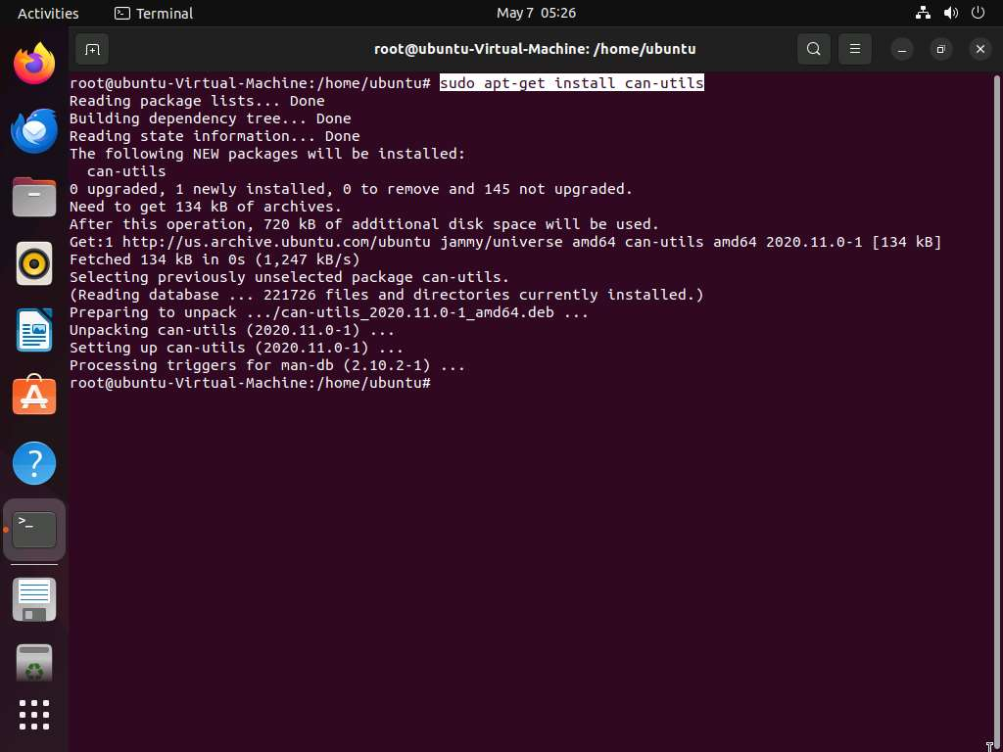
- Now, to set up a virtual CAN interface issue following commands:
  - sudo modprobe can
  - sudo modprobe vcan
  - sudo ip link add dev vcan0 type vcan
  - sudo ip link set up vcan0
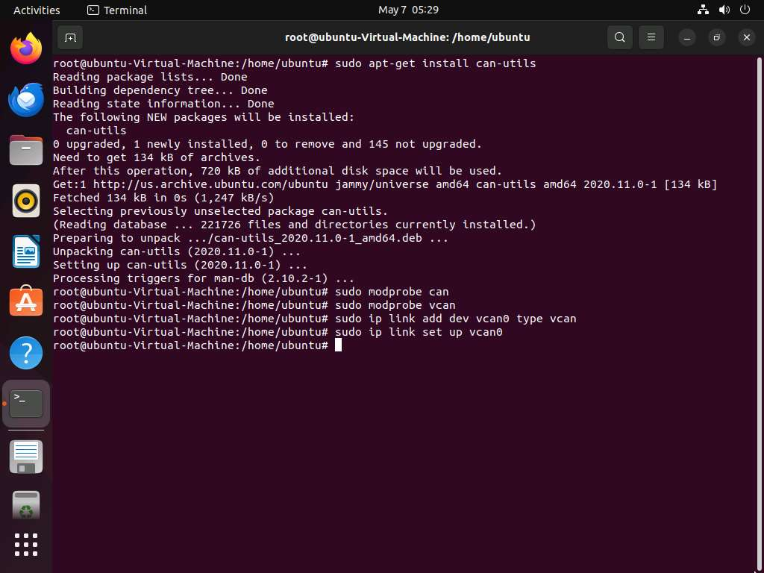
- To check whether Virtual CAN interface is setup successfully, run ifconfig. Here, vcan0 interface is present which confirms that our Virtual CAN interface is set up successfully.
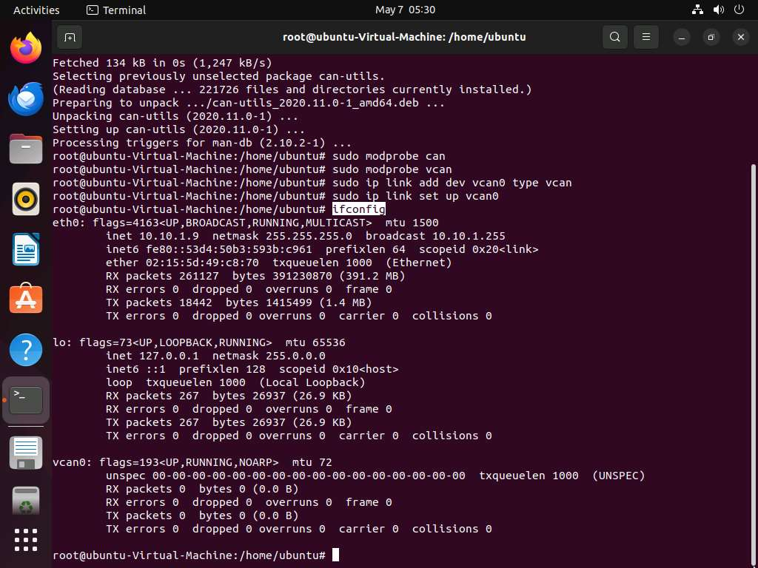
- Run chmod -R 777 ICSim to give permissions to the ICSim folder.
- Now, run cd ICSim to navigate to ICSim directory and execute make command to create two executable files for IC Simulator and CANBus Control Panel.
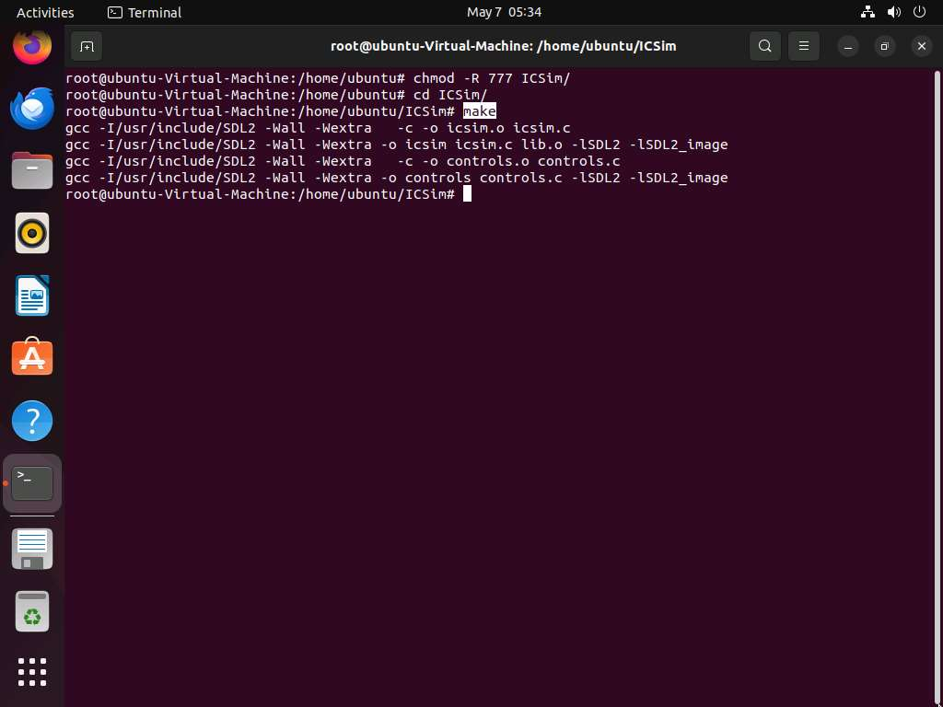
- Run ./icsim vcan0 to start the ICSim simulator. You will see the IC Simulator interface as shown in the screenshot.
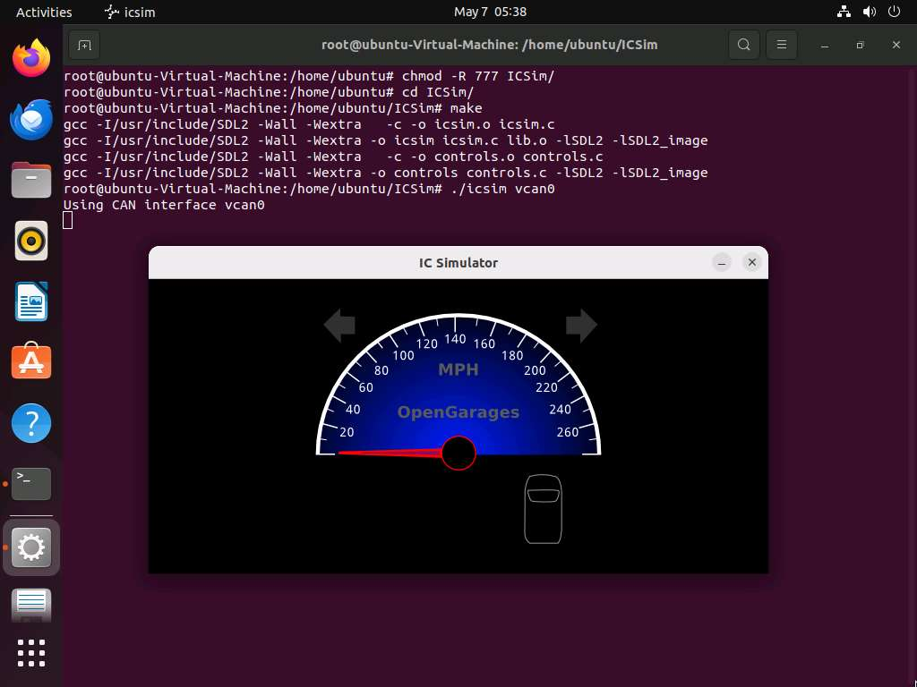
- Open a new terminal tab and execute sudo su to run the programs as a root user (When prompted, enter the password toor). Navigate to ICSim directory to do so run cd ICSim/.
- Execute ./controls vcan0 to start the CANBus Control Panel. You will see the CANBus Control Panel interface as shown in the screenshot.
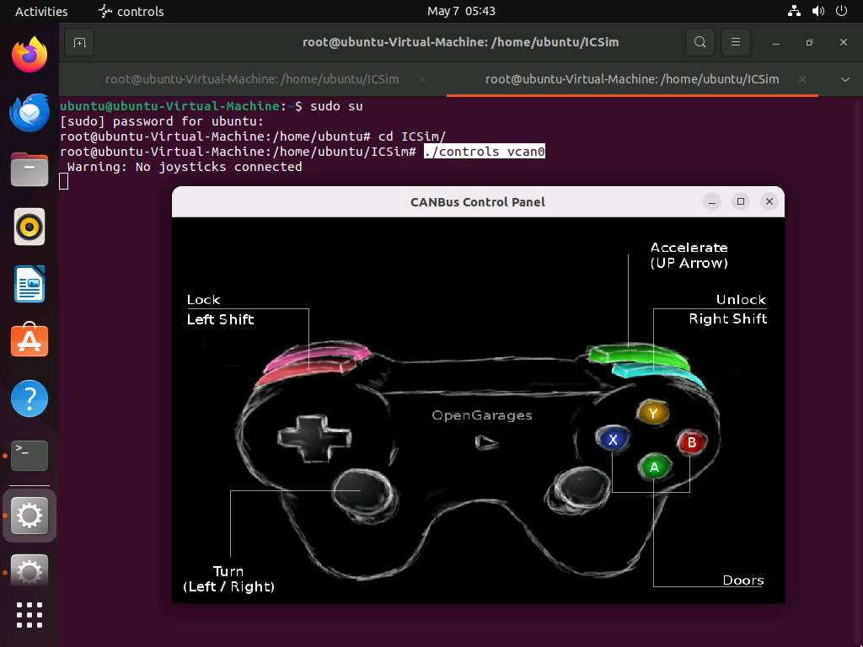
- Now, we will start sniffer to capture the traffic sent to the ICSim Simulator by CANBus control panel simulator. To do so, open a new terminal tab and execute sudo su to run the programs as a root user (When prompted, enter the password toor). Navigate to ICSim directory to do so run cd ICSim/.
- Execute cansniffer -c vcan0 to start sniffing on the vcan0 interface. Leave this sniffer on.
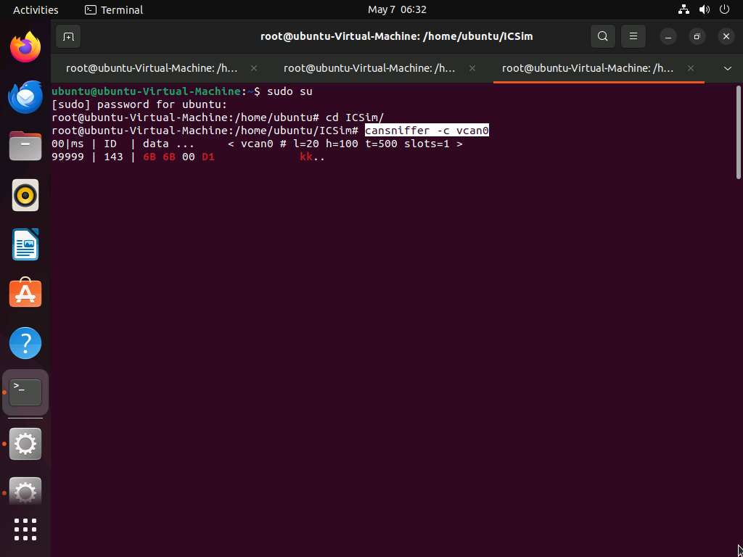
- Open a new terminal and execute sudo su to run the programs as a root user (When prompted, enter the password toor). Navigate to ICSim directory to do so run cd ICSim/. To capture the logs run candump -l vcan0.
- After starting to capture the logs, open ICSim and Controller simulator and perform functions such as acceleration, turning left/right, opening and locking doors so that logs are generated. Once you are done, terminate the ongoing process by pressing Ctrl + C.
Use the following keys to perform various functions
ICSim Functions | Keys
Accelerate | Up arrow
Left/Right Turn | Left arrow/ Right arrow
Unlock Rear Left/Right doors | Right Shift + X / Right Shift + Y
Unlock Front Left/Right doors | Right Shift +A / Right Shift + B
Lock all doors | Hold Right Shift key + Tap Left Shift
Unlock all doors | Hold Left Shift key + Tap Right Shift
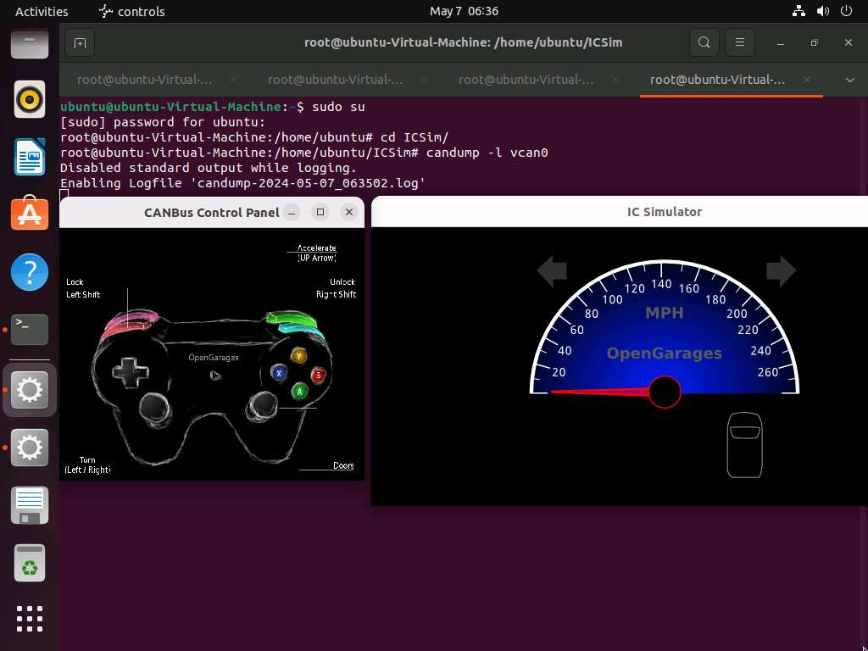
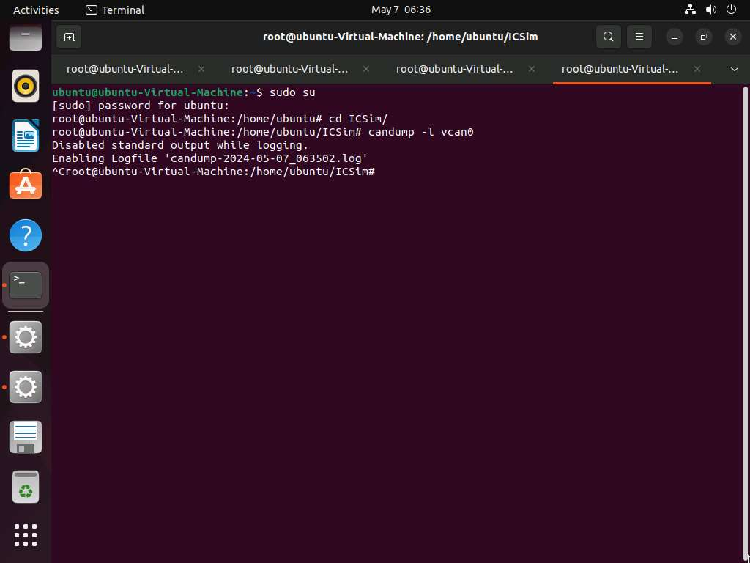
- Now verify if you have obtained the log file by executing ls command. The .log file has been generated as shown in the screenshot.
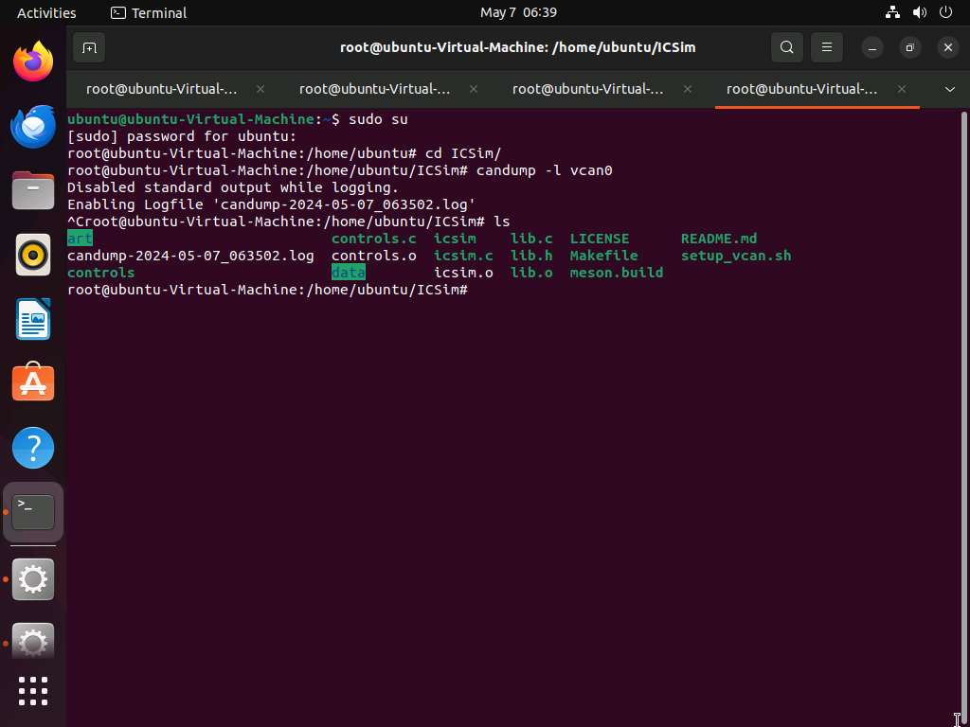
- Now, to perform replay attack, run canplayer -I candump-2024-05-07_063502.log and press enter.
Once the log file is executed, you can see the movements that were performed while creating the log file in real time in IC Simulator and CANBus control panel simulator.
The log file name might vary while performing lab.
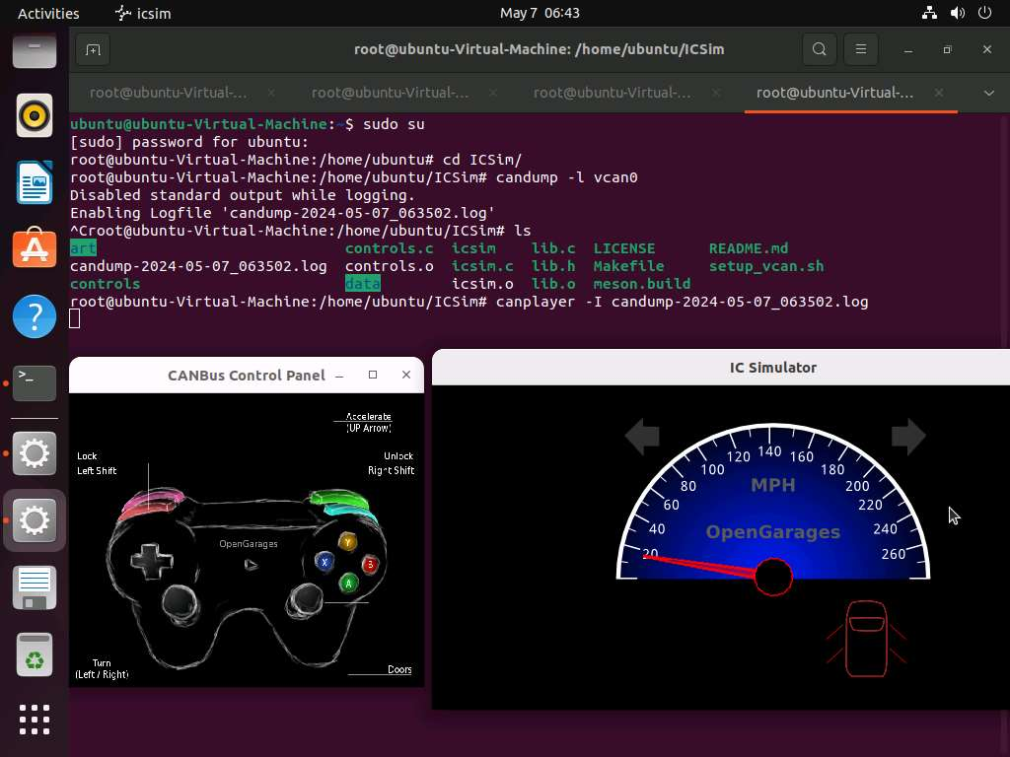
- This concludes the demonstration of performing replay attack to exploit CAN protocol.
- Close all open windows and document all the acquired information.
Question 18.3.1.1
In Ubuntu machine install ICSim simulator, start a CAN sniffer and perform functions such as acceleration, turning left/right, opening and locking doors in the simulator to generate the logs. Perform replay attack using the sniffed log file. Enter the interface that is used while sniffing the can traffic in Ubuntu.

